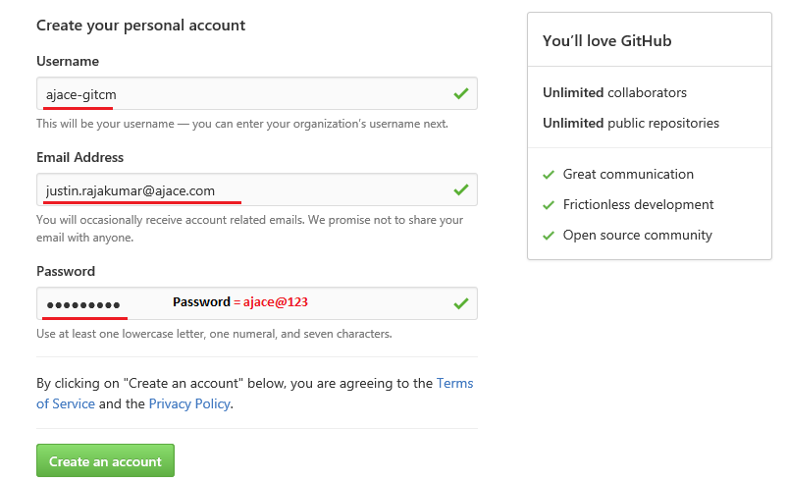

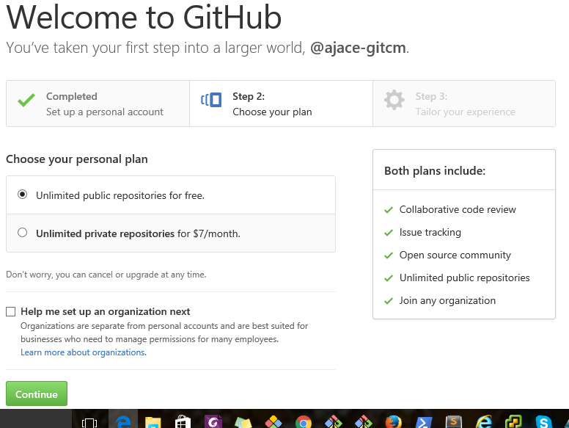



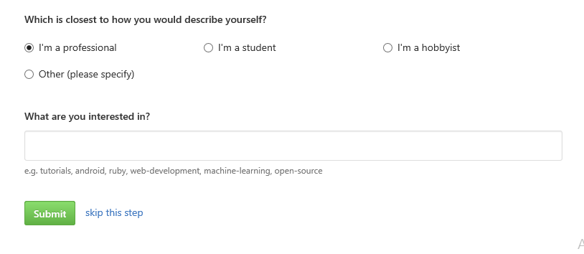



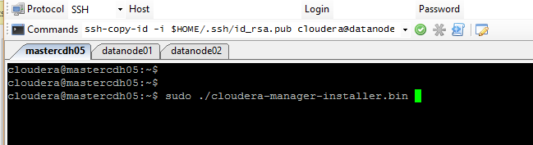

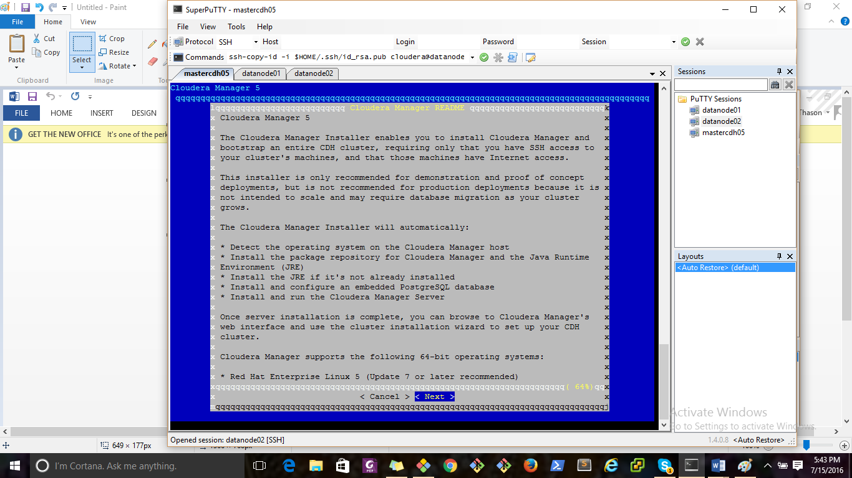

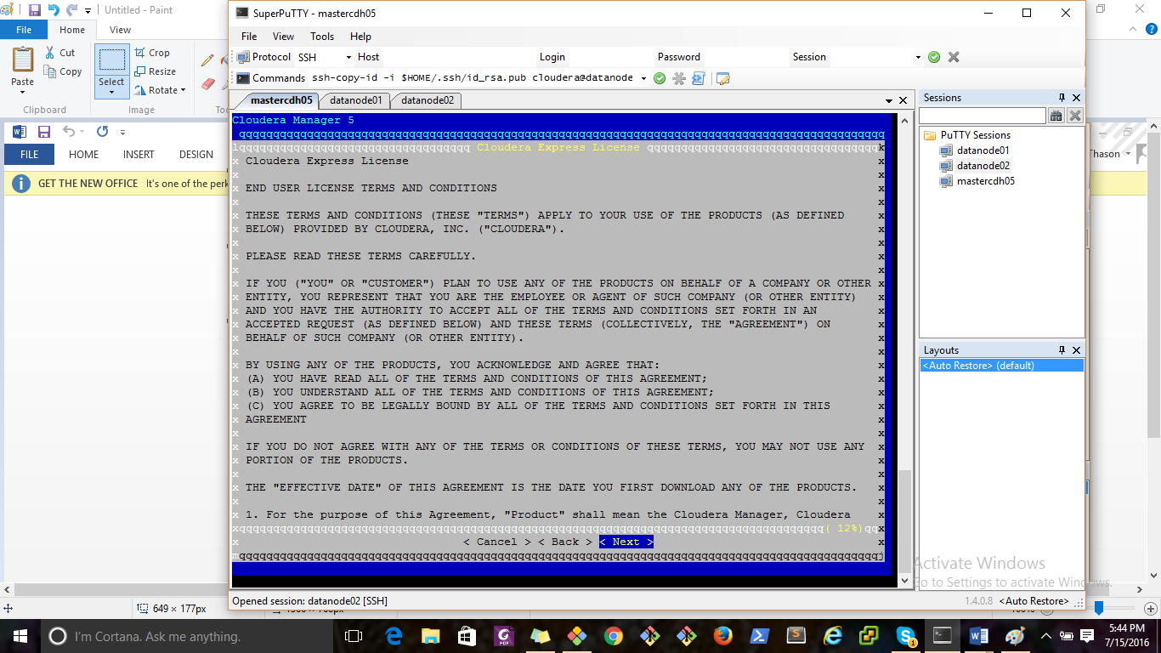

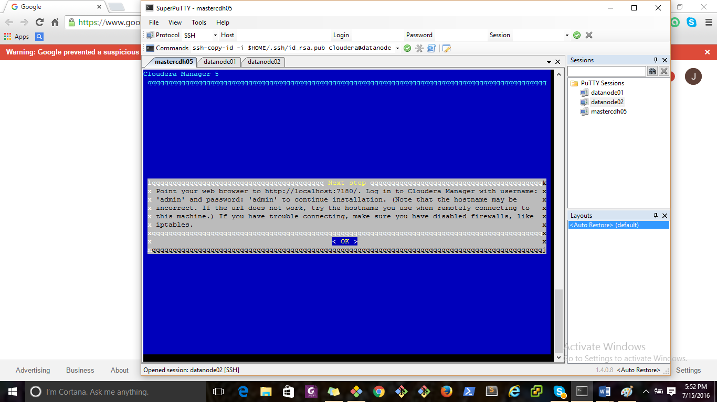

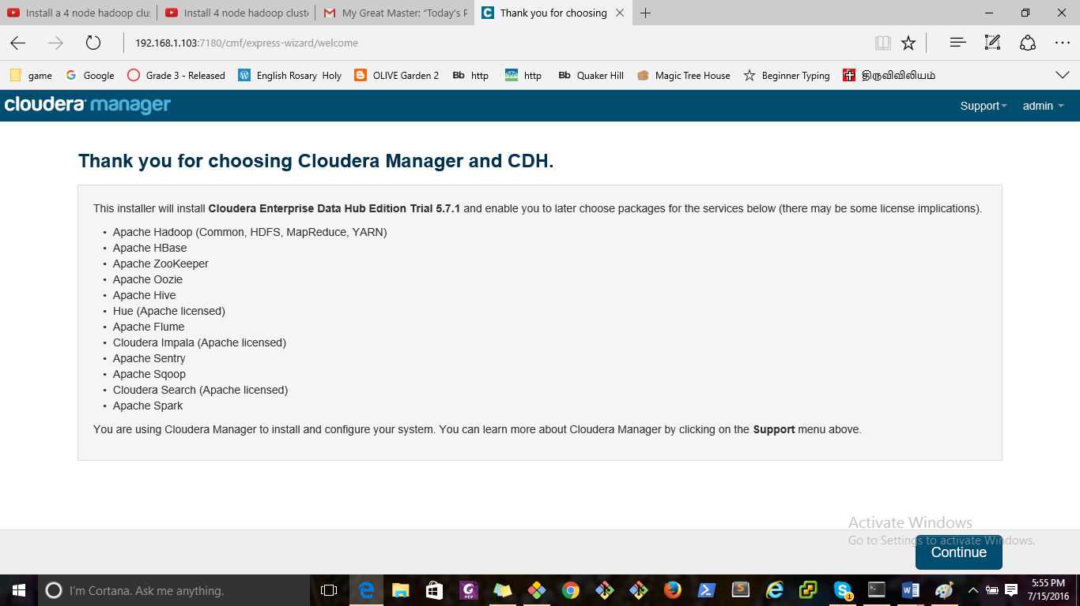

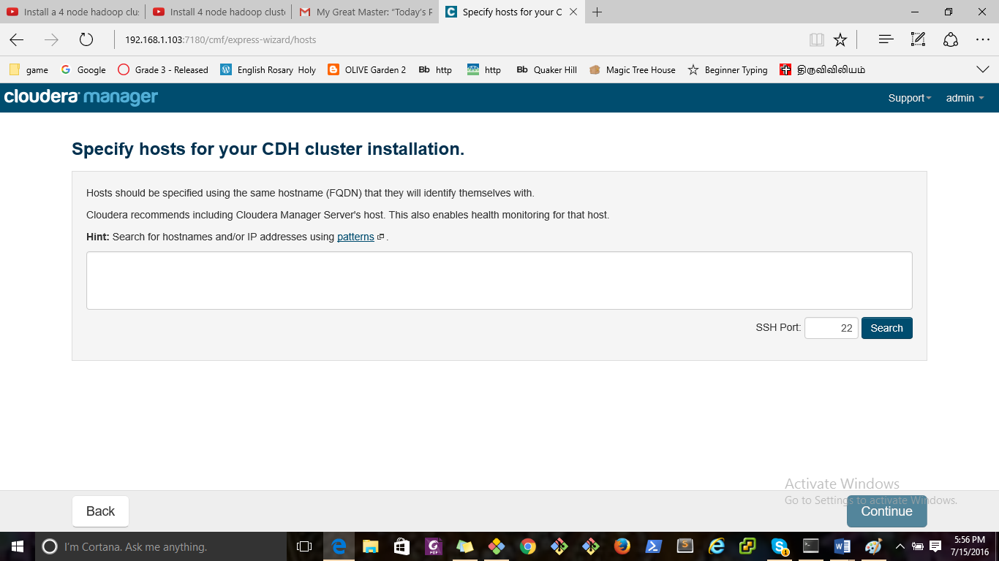

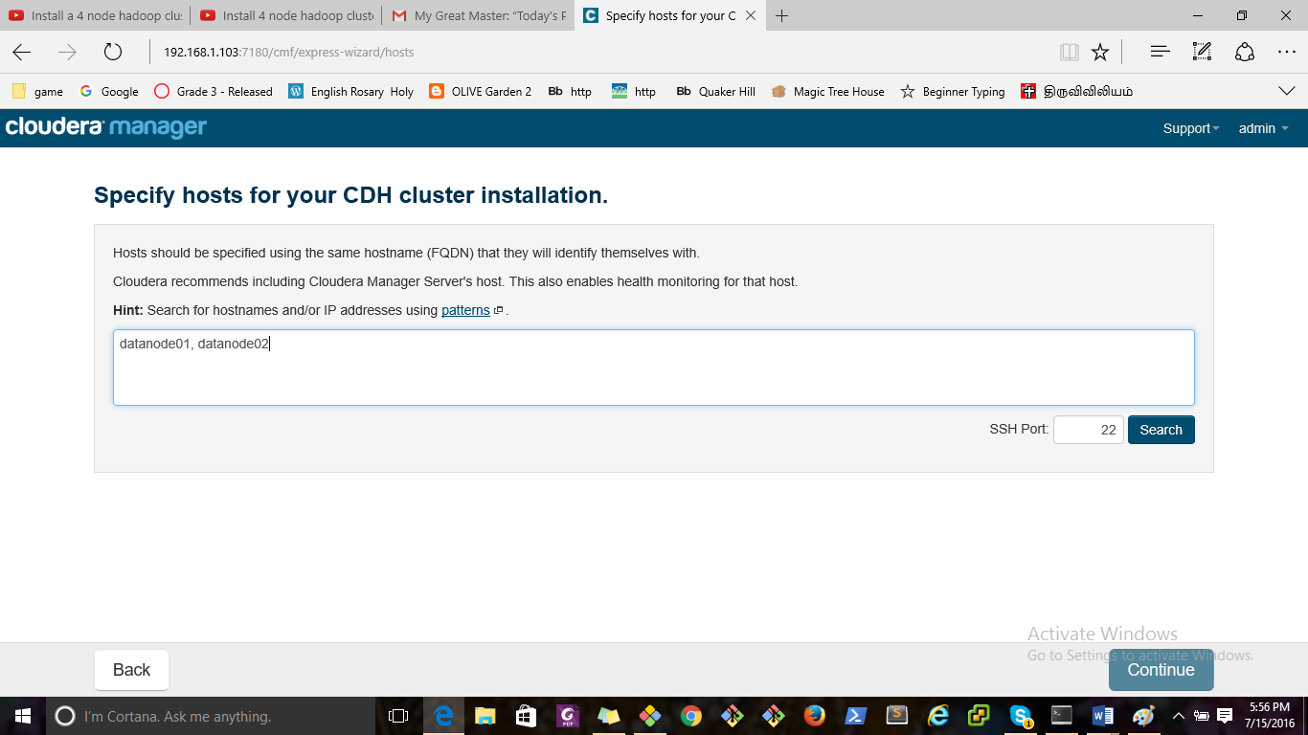

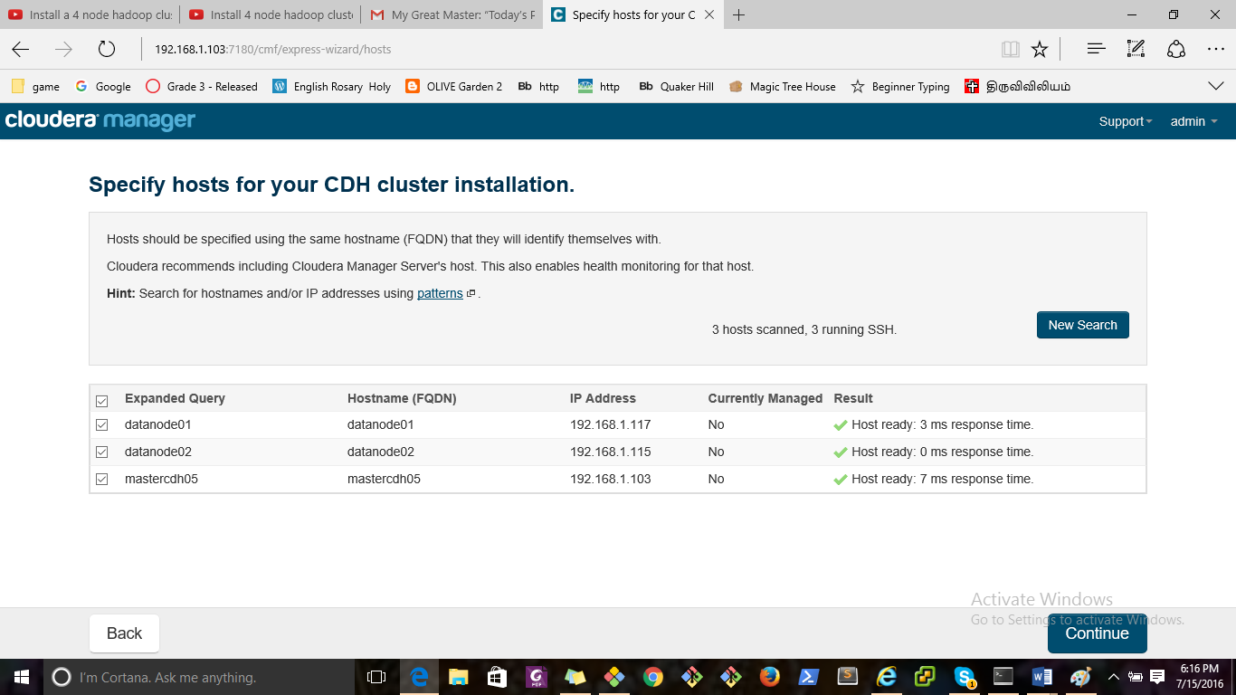

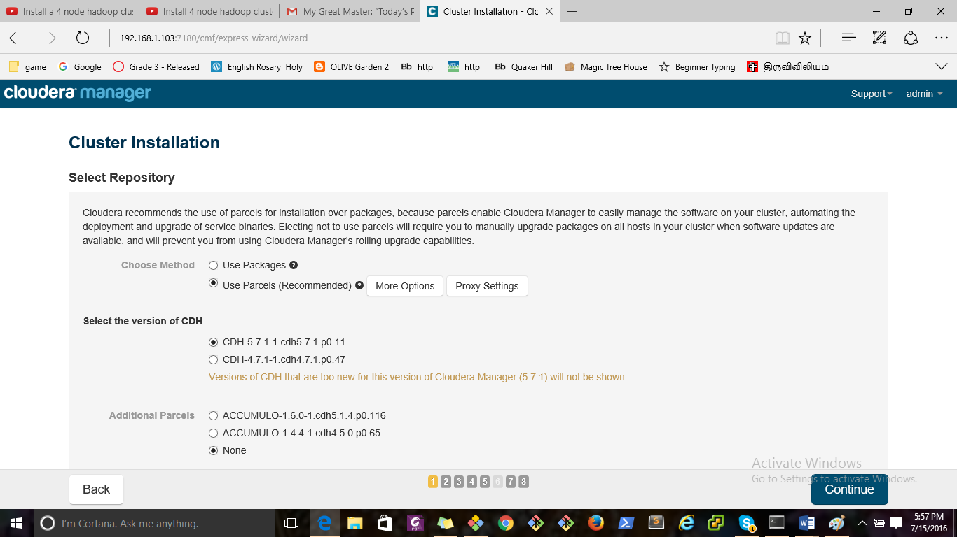

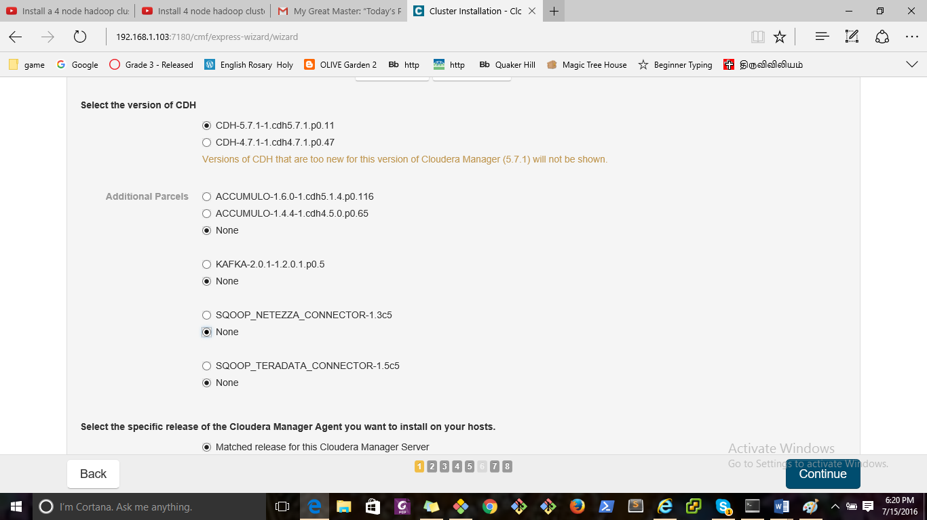

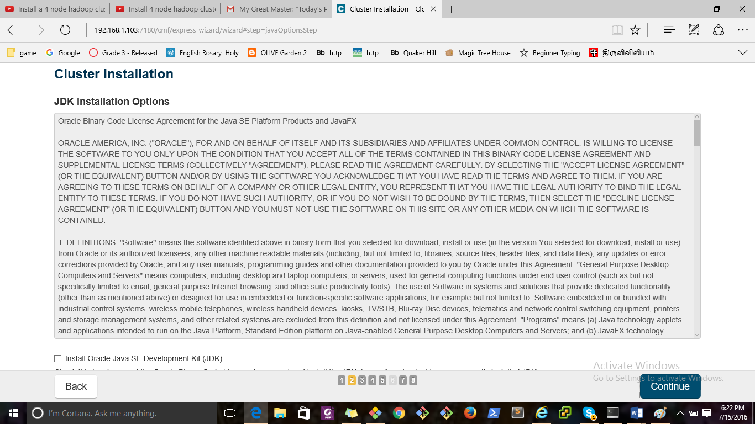

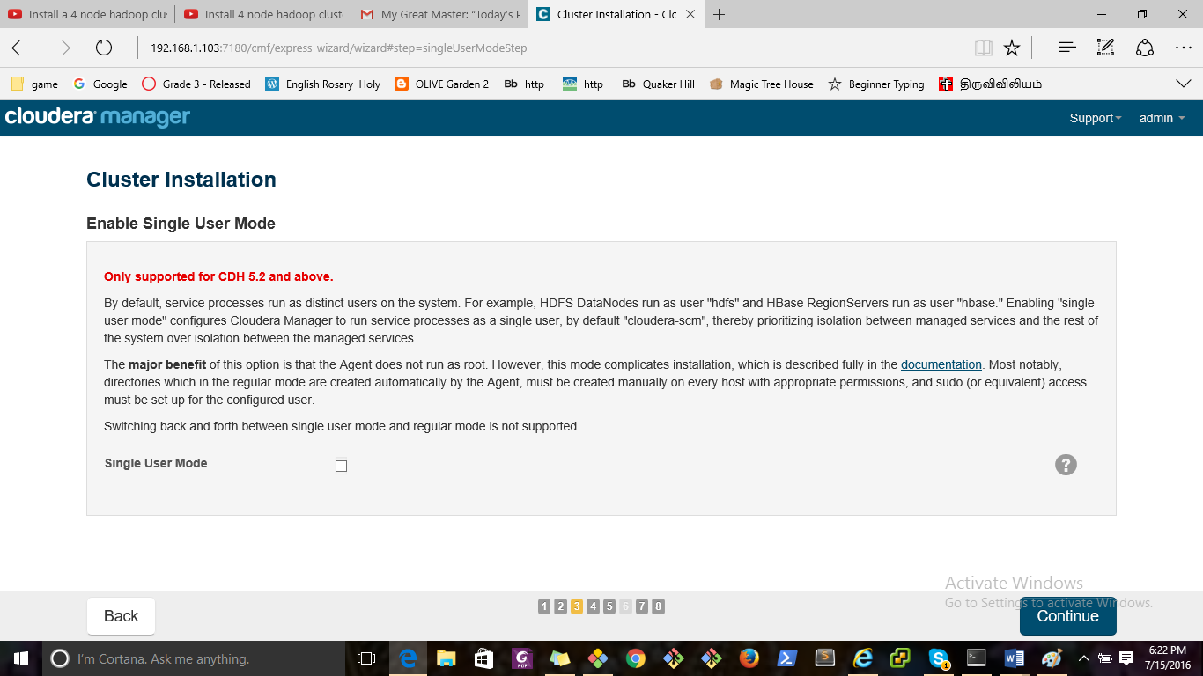

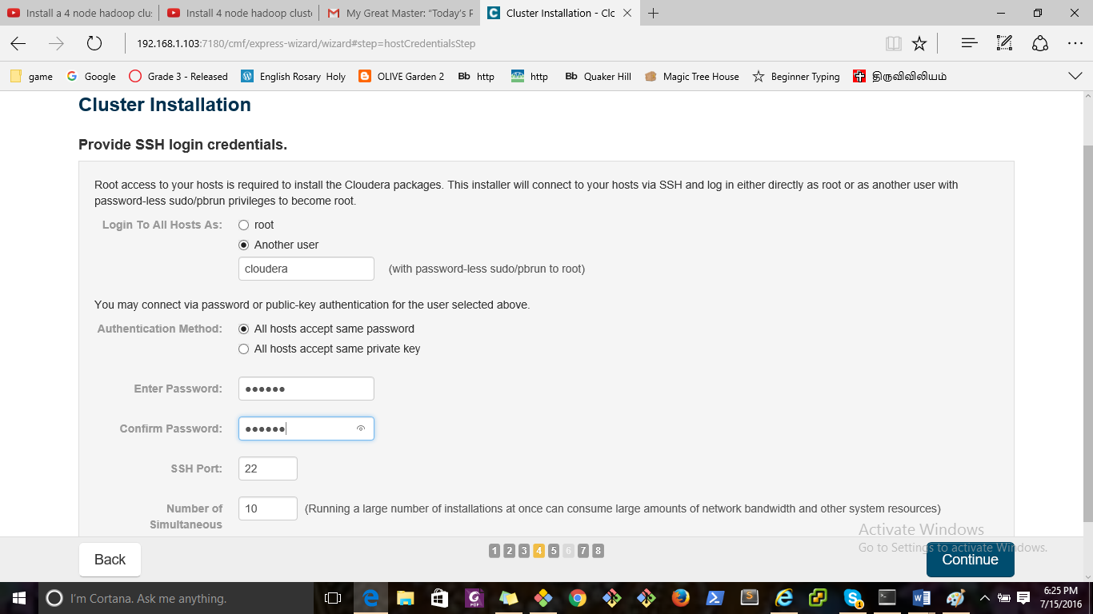

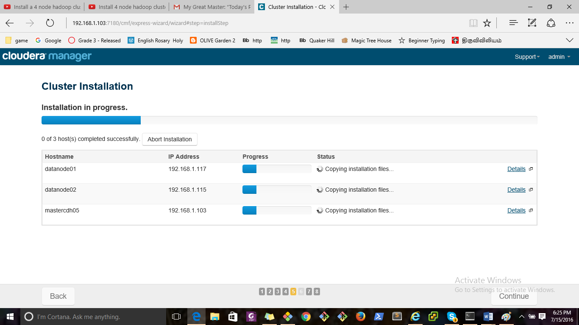

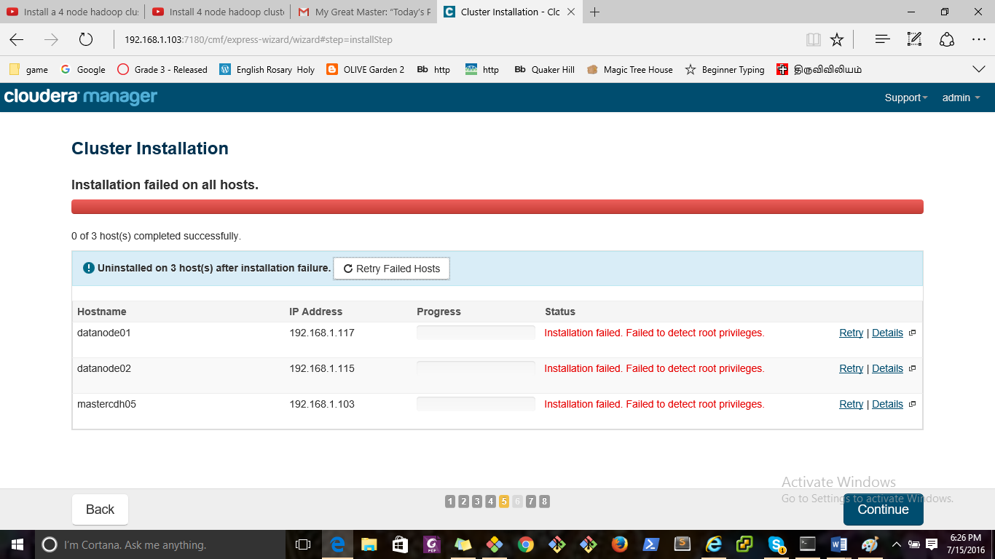

To resolve the issue, please follow the below steps

Login into all the indivdial servers

Execute the below commands

#sudo visudo

Please enter the below file into opened file

Cloudera ALL=(ALL:ALL) NOPASSWD: ALL

If it is nano Press ctrl+o and enter, ctrl+x and enter (Save the file and exit)

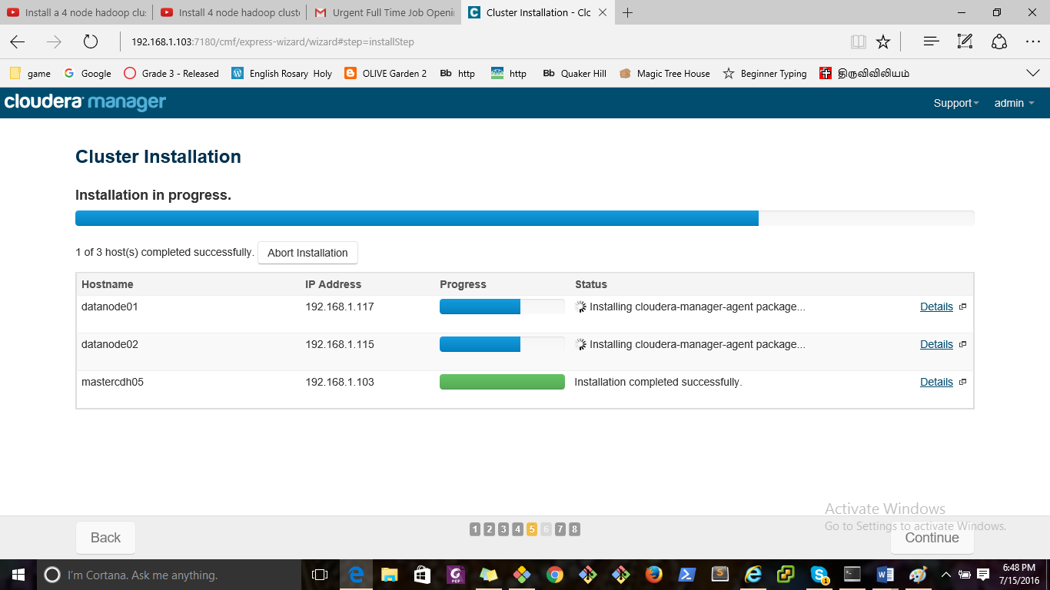

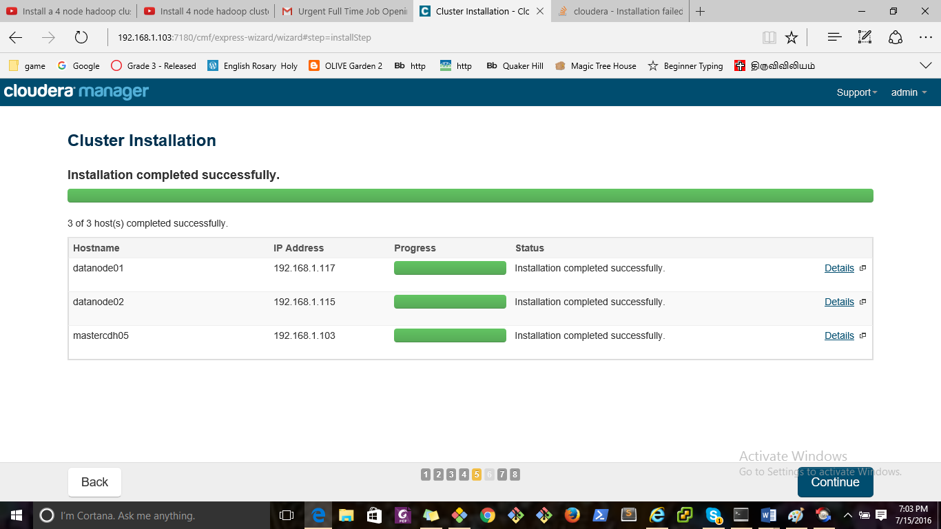

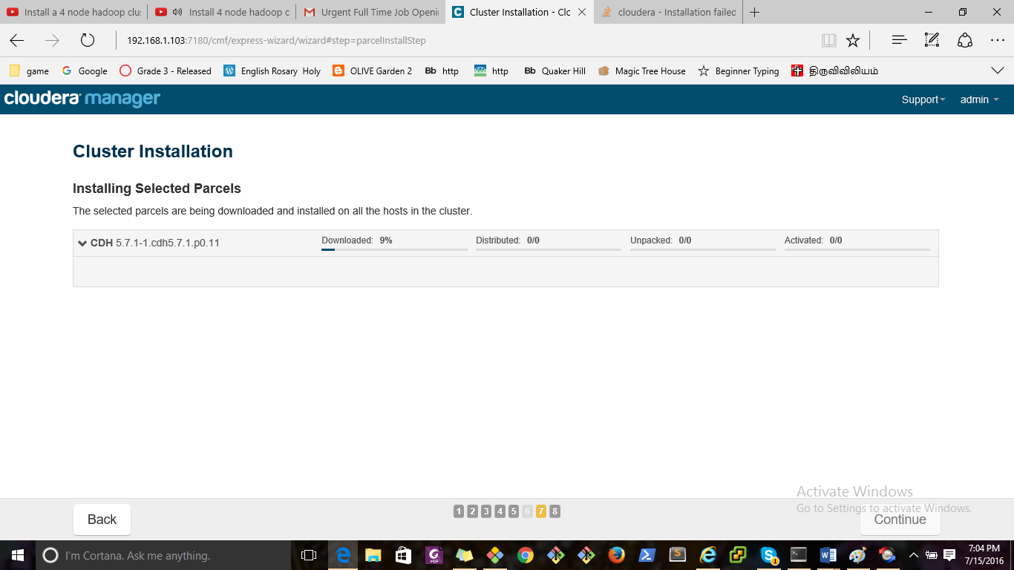

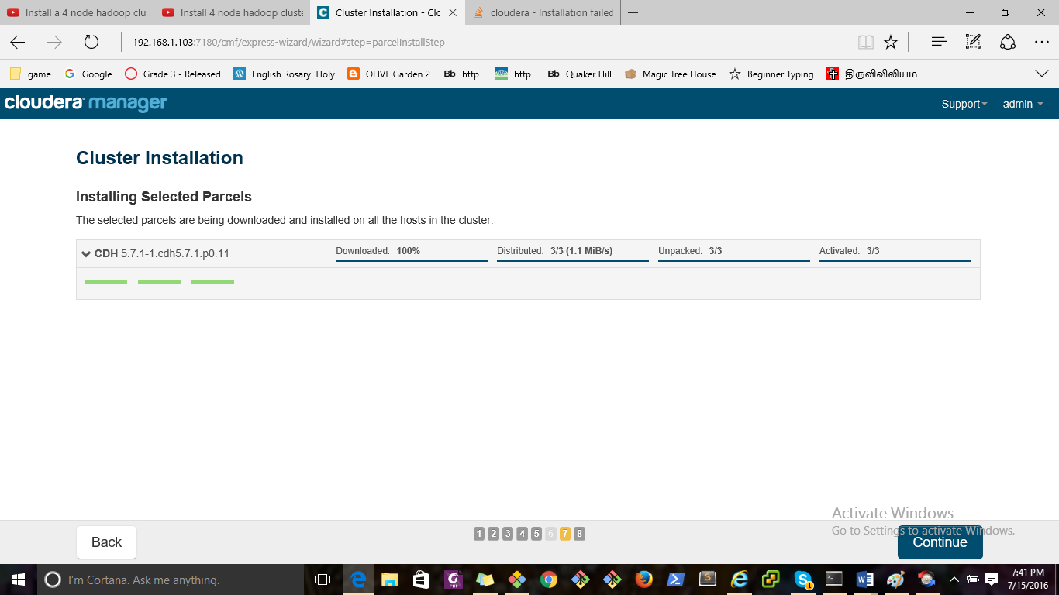

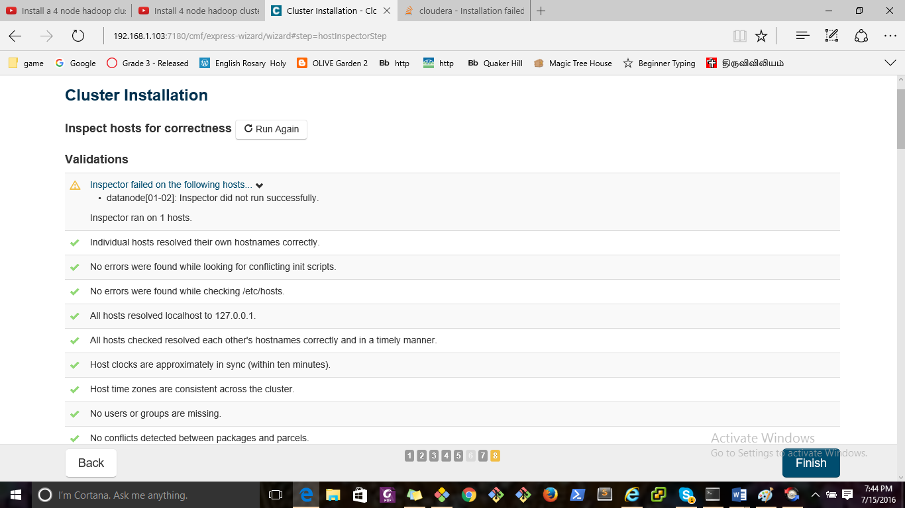

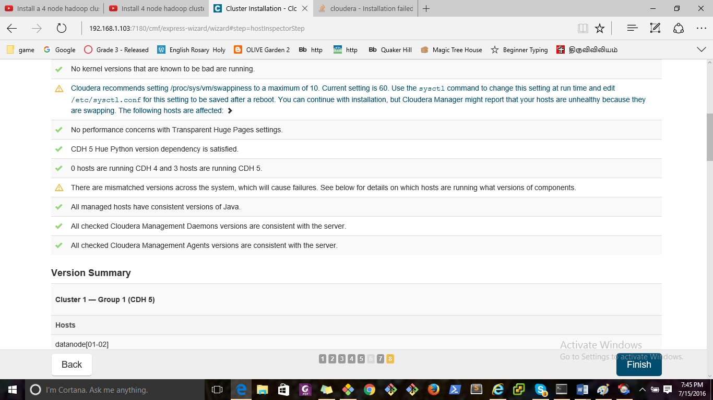

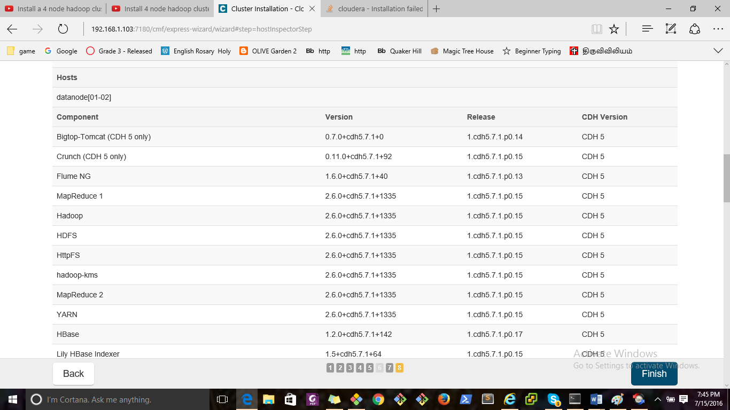

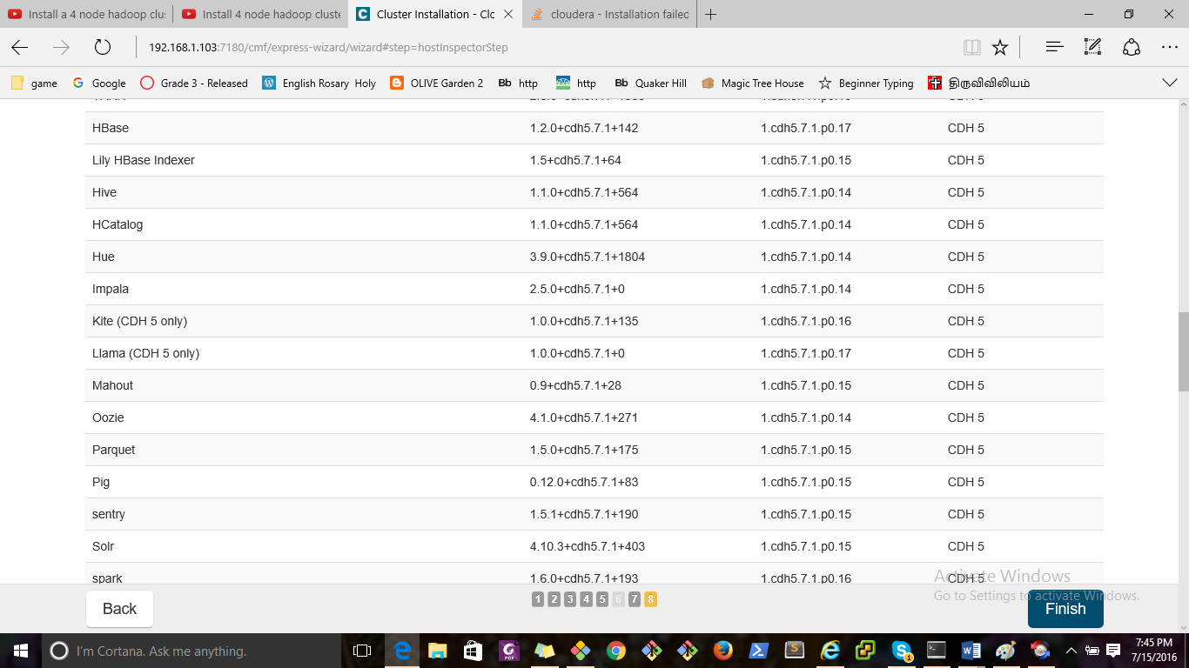

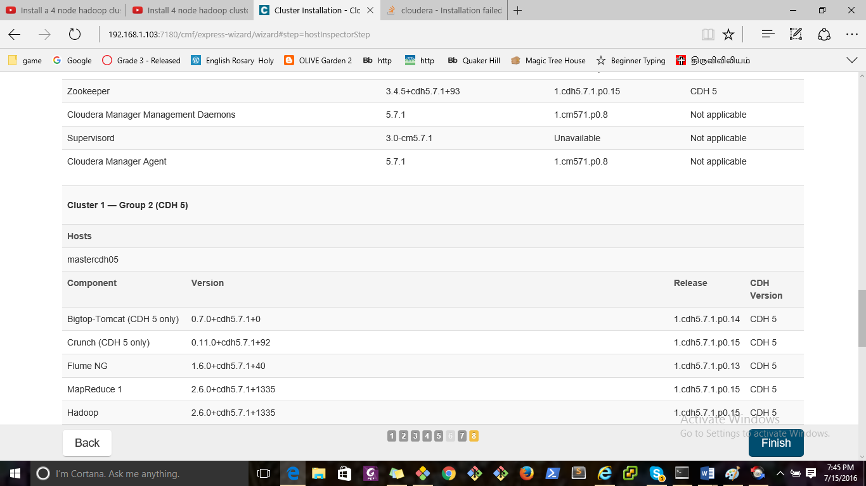

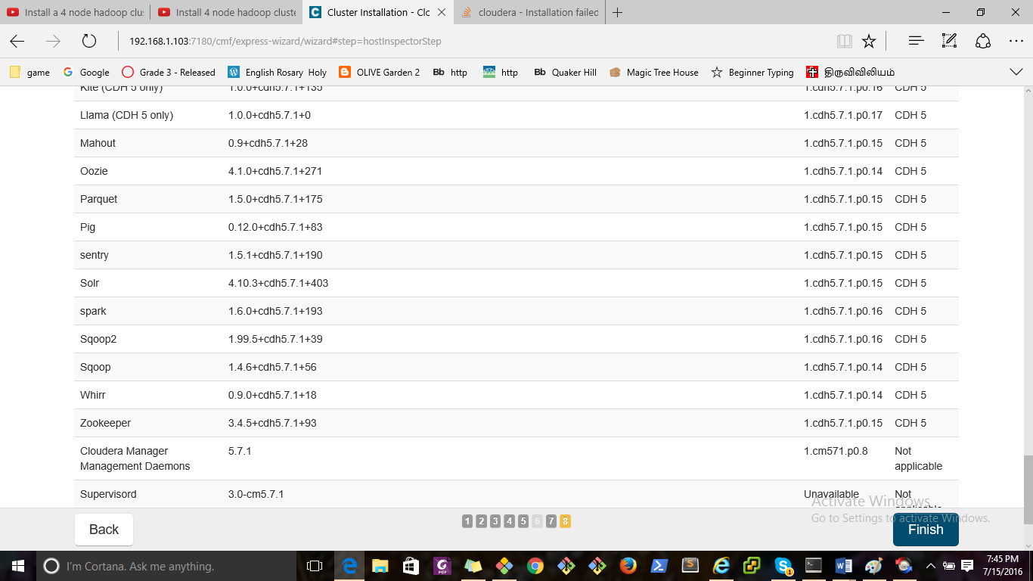

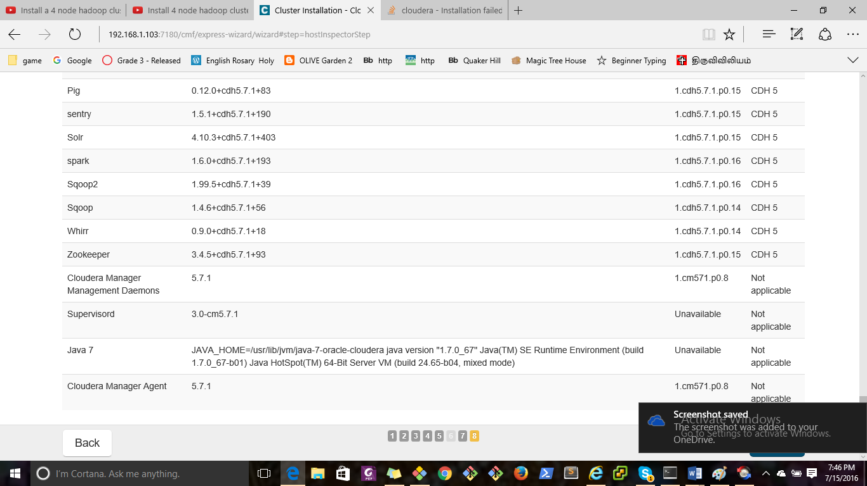

Cloudera Manager

[Support](http://192.168.1.103:7180/cmf/express-wizard/wizard)

[Support Portal](http://support.cloudera.com/)

[Scheduled Diagnostics: Weekly](http://192.168.1.103:7180/cmf/settings?groupKey=config.scm.support.display_group)

[Help](http://192.168.1.103:7180/cmf/help/scm-help-guide)

[Installation Guide](http://192.168.1.103:7180/cmf/help/scm-install-guide)

[API Documentation](http://192.168.1.103:7180/static/apidocs/)

[Release Notes](http://tiny.cloudera.com/cm-rel-notes-5.7)

[About](http://192.168.1.103:7180/cmf/help/about)

[admin](http://192.168.1.103:7180/cmf/express-wizard/wizard)

Full Administrator

[Change Password](http://192.168.1.103:7180/cmf/password)

[Logout](http://192.168.1.103:7180/cmf/logout)

×

Close

×

Confirm

OK Cancel

Cluster Installation

Top of Form

Select Repository

Cloudera recommends the use of parcels for installation over packages, because parcels enable Cloudera Manager to easily manage the software on your cluster, automating the deployment and upgrade of service binaries. Electing not to use parcels will require you to manually upgrade packages on all hosts in your cluster when software updates are available, and will prevent you from using Cloudera Manager's rolling upgrade capabilities.

Choose Method

Use Packages Use Parcels (Recommended) [More Options](http://192.168.1.103:7180/cmf/config2/dialog?task=ALL_PARCEL_REPOSITORY_SETTINGS) [Proxy Settings](http://192.168.1.103:7180/cmf/config2/dialog?task=ALL_PROXY_SETTINGS)

Select the version of CDH

CDH-5.7.1-1.cdh5.7.1.p0.11 CDH-4.7.1-1.cdh4.7.1.p0.47

Versions of CDH that are too new for this version of Cloudera Manager (5.7.1) will not be shown.

Additional Parcels

ACCUMULO-1.6.0-1.cdh5.1.4.p0.116 ACCUMULO-1.4.4-1.cdh4.5.0.p0.65 None

KAFKA-2.0.1-1.2.0.1.p0.5 None

SQOOP_NETEZZA_CONNECTOR-1.3c5 None

SQOOP_TERADATA_CONNECTOR-1.5c5 None



Select the specific release of the Cloudera Manager Agent you want to install on your hosts.

Matched release for this Cloudera Manager Server Custom Repository



Example for SLES, Redhat or other RPM based distributions:

https://archive.cloudera.com/cm5/redhat/6/x86_64/cm/5/

Example for Ubuntu or other Debian based distributions:

deb https://archive.cloudera.com/cm5/ubuntu/lucid/amd64/cm/ lucid-cm5 contrib

Enter a custom URL for the location of the GPG signing key (applies to all custom repositories and without Internet access).

Custom GPG Key URL: 

Example for SLES, Redhat or other RPM based distributions:

https://archive.cloudera.com/cm5/redhat/6/x86_64/cm/RPM-GPG-KEY-cloudera

Example for Ubuntu or other Debian based distributions:

https://archive.cloudera.com/cm5/debian/squeeze/amd64/cm/archive.key

JDK Installation Options



Install Oracle Java SE Development Kit (JDK)

Check this box to accept the Oracle Binary Code License Agreement and install the JDK. Leave it unchecked to use a currently installed JDK.

Install Java Unlimited Strength Encryption Policy Files

Check this checkbox if local laws permit you to deploy unlimited strength encryption and you are running a secure cluster.

Enable Single User Mode

Only supported for CDH 5.2 and above.

By default, service processes run as distinct users on the system. For example, HDFS DataNodes run as user "hdfs" and HBase RegionServers run as user "hbase." Enabling "single user mode" configures Cloudera Manager to run service processes as a single user, by default "cloudera-scm", thereby prioritizing isolation between managed services and the rest of the system over isolation between the managed services.

The major benefit of this option is that the Agent does not run as root. However, this mode complicates installation, which is described fully in the [documentation](http://tiny.cloudera.com/cm-single-user-mode). Most notably, directories which in the regular mode are created automatically by the Agent, must be created manually on every host with appropriate permissions, and sudo (or equivalent) access must be set up for the configured user.

Switching back and forth between single user mode and regular mode is not supported.

Single User Mode

0 overrides removed

Requires Agent Restart

Requires Server Restart

Edit Identical Values

Edit Individual Values



Manage Host Overrides

Configure all clusters to run in single user mode where the Cloudera Manager agent and all service processes run as the same system user. Only supported for CDH 5.2 and higher.

Provide SSH login credentials.

Root access to your hosts is required to install the Cloudera packages. This installer will connect to your hosts via SSH and log in either directly as root or as another user with password-less sudo/pbrun privileges to become root.

Login To All Hosts As:

root Another user (with password-less sudo/pbrun to root)

You may connect via password or public-key authentication for the user selected above.

Authentication Method:

All hosts accept same password All hosts accept same private key

Enter Password:



Confirm Password:



Private Key File:

Enter Passphrase:



Confirm Passphrase:



SSH Port:



Number of Simultaneous Installations:

(Running a large number of installations at once can consume large amounts of network bandwidth and other system resources)

Continue SSH login with no password?

Continue SSH login with no passphrase?

The passwords you entered do not match. Please try again.

The passphrases you entered do not match. Please try again.

Please enter a username.

The Private Key File must be provided.



Bottom of Form

Installation completed successfully.

3 of 3 host(s) completed successfully. Abort Installation

Uninstalled on 0 host(s) after installation failure. Retry Failed Hosts

Installation failed on 0 host(s). Uninstall Failed Hosts Retry Failed Hosts

| Hostname | IP Address | Progress | Status |
| --- | --- | --- | --- |
| datanode01 | 192.168.1.117 |  | [Retry](http://192.168.1.103:7180/cmf/express-wizard/wizard) | [Uninstall](http://192.168.1.103:7180/cmf/express-wizard/wizard) | [Details](http://192.168.1.103:7180/cmf/express-wizard/wizard)  Installation completed successfully. |
| datanode02 | 192.168.1.115 |  | [Retry](http://192.168.1.103:7180/cmf/express-wizard/wizard) | [Uninstall](http://192.168.1.103:7180/cmf/express-wizard/wizard) | [Details](http://192.168.1.103:7180/cmf/express-wizard/wizard)  Installation completed successfully. |
| mastercdh05 | 192.168.1.103 |  | [Retry](http://192.168.1.103:7180/cmf/express-wizard/wizard) | [Uninstall](http://192.168.1.103:7180/cmf/express-wizard/wizard) | [Details](http://192.168.1.103:7180/cmf/express-wizard/wizard)  Installation completed successfully. |

Installation completed successfully. (Current Step) Last Refreshed: Jul 15, 2016 7:00:43 PM EDT

/tmp/scm_prepare_node.jWZYLFcY   
using SSH_CLIENT to get the SCM hostname: 192.168.1.103 48278 22   
opening logging file descriptor

Starting installation script...

Acquiring installation lock...

BEGIN flock 4   
END (0)

Detecting root privileges...

effective UID is 1000   
BEGIN which pbrun   
END (1)   
BEGIN sudo -S id   
uid=0(root) gid=0(root) groups=0(root)   
END (0)   
Using 'sudo ' to acquire root privileges

Detecting distribution...

BEGIN grep 'Ubuntu' /etc/lsb-release   
END (0)   
BEGIN grep DISTRIB_CODENAME /etc/lsb-release   
DISTRIB_ID=Ubuntu   
DISTRIB_DESCRIPTION="Ubuntu 14.04.4 LTS"   
END (0)   
DISTRIB_CODENAME=trusty   
BEGIN echo DISTRIB_CODENAME=trusty | cut -d = -f 2   
trusty   
END (0)

Detecting Cloudera Manager Server...

BEGIN host -t PTR 192.168.1.103   
Host 103.1.168.192.in-addr.arpa. not found: 3(NXDOMAIN)   
END (1)   
BEGIN which python   
END (0)   
BEGIN python -c 'import socket; import sys; s = socket.socket(socket.AF_INET); s.settimeout(5.0); s.connect((sys.argv[1], int(sys.argv[2]))); s.close();' 192.168.1.103 7182   
/usr/bin/python   
END (0)   
BEGIN which wget   
END (0)   
/usr/bin/wget   
BEGIN wget -qO- -T 1 -t 1 http://169.254.169.254/latest/meta-data/public-hostname && /bin/echo   
END (4)

Installing package repositories...

validating format of repository file /tmp/scm_prepare_node.jWZYLFcY/repos/ubuntu_trusty/cloudera-manager.list   
installing repository file /tmp/scm_prepare_node.jWZYLFcY/repos/ubuntu_trusty/cloudera-manager.list   
repository file /tmp/scm_prepare_node.jWZYLFcY/repos/ubuntu_trusty/cloudera-manager.list installed   
BEGIN sudo apt-key add /tmp/scm_prepare_node.jWZYLFcY/archive.key   
OK   
END (0)   
installing priority file /tmp/scm_prepare_node.jWZYLFcY/priorities/ubuntu_trusty/cloudera.pref   
priority file /tmp/scm_prepare_node.jWZYLFcY/priorities/ubuntu_trusty/cloudera.pref installed

Refreshing package metadata...

BEGIN sudo apt-get update   
Hit http://archive.cloudera.com trusty-cm5 InRelease   
Ign http://us.archive.ubuntu.com trusty InRelease   
Hit http://archive.cloudera.com trusty-cm5/contrib Sources   
Get:1 http://us.archive.ubuntu.com trusty-updates InRelease [65.9 kB]   
Hit http://archive.cloudera.com trusty-cm5/contrib amd64 Packages   
Hit http://us.archive.ubuntu.com trusty-backports InRelease   
Get:2 http://security.ubuntu.com trusty-security InRelease [65.9 kB]   
Hit http://us.archive.ubuntu.com trusty Release.gpg   
Get:3 http://us.archive.ubuntu.com trusty-updates/main Sources [279 kB]   
Get:4 http://us.archive.ubuntu.com trusty-updates/restricted Sources [5,352 B]   
Ign http://archive.cloudera.com trusty-cm5/contrib Translation-en_US   
Ign http://archive.cloudera.com trusty-cm5/contrib Translation-en   
Get:5 http://us.archive.ubuntu.com trusty-updates/universe Sources [158 kB]   
Get:6 http://us.archive.ubuntu.com trusty-updates/multiverse Sources [5,929 B]   
Get:7 http://us.archive.ubuntu.com trusty-updates/main amd64 Packages [799 kB]   
Get:8 http://us.archive.ubuntu.com trusty-updates/restricted amd64 Packages [15.9 kB]   
Get:9 http://us.archive.ubuntu.com trusty-updates/universe amd64 Packages [364 kB]   
Get:10 http://security.ubuntu.com trusty-security/main Sources [118 kB]   
Get:11 http://us.archive.ubuntu.com trusty-updates/multiverse amd64 Packages [13.2 kB]   
Get:12 http://us.archive.ubuntu.com trusty-updates/main i386 Packages [766 kB]   
Get:13 http://us.archive.ubuntu.com trusty-updates/restricted i386 Packages [15.6 kB]   
Get:14 http://us.archive.ubuntu.com trusty-updates/universe i386 Packages [365 kB]   
Get:15 http://security.ubuntu.com trusty-security/restricted Sources [4,035 B]   
Get:16 http://us.archive.ubuntu.com trusty-updates/multiverse i386 Packages [13.6 kB]   
Hit http://us.archive.ubuntu.com trusty-updates/main Translation-en   
Get:17 https://archive.cloudera.com trusty-cm5.7.1 InRelease   
Get:18 http://security.ubuntu.com trusty-security/universe Sources [38.0 kB]   
Hit http://us.archive.ubuntu.com trusty-updates/multiverse Translation-en   
Get:19 https://archive.cloudera.com trusty-cm5.7.1/contrib amd64 Packages   
Get:20 http://security.ubuntu.com trusty-security/multiverse Sources [2,760 B]   
Get:21 https://archive.cloudera.com trusty-cm5.7.1/contrib Translation-en_US   
Hit http://us.archive.ubuntu.com trusty-updates/restricted Translation-en   
Hit http://us.archive.ubuntu.com trusty-updates/universe Translation-en   
Hit http://us.archive.ubuntu.com trusty Release   
Get:22 http://security.ubuntu.com trusty-security/main amd64 Packages [511 kB]   
Hit http://us.archive.ubuntu.com trusty-backports/main Sources   
Hit http://us.archive.ubuntu.com trusty-backports/restricted Sources   
Ign https://archive.cloudera.com trusty-cm5.7.1/contrib Translation-en_US   
Hit http://us.archive.ubuntu.com trusty-backports/universe Sources   
Ign https://archive.cloudera.com trusty-cm5.7.1/contrib Translation-en   
Hit http://us.archive.ubuntu.com trusty-backports/multiverse Sources   
Hit http://us.archive.ubuntu.com trusty-backports/main amd64 Packages   
Hit http://us.archive.ubuntu.com trusty-backports/restricted amd64 Packages   
Hit http://us.archive.ubuntu.com trusty-backports/universe amd64 Packages   
Hit http://us.archive.ubuntu.com trusty-backports/multiverse amd64 Packages   
Get:23 http://security.ubuntu.com trusty-security/restricted amd64 Packages [13.0 kB]   
Hit http://us.archive.ubuntu.com trusty-backports/main i386 Packages   
Hit http://us.archive.ubuntu.com trusty-backports/restricted i386 Packages   
Hit http://us.archive.ubuntu.com trusty-backports/universe i386 Packages   
Get:24 http://security.ubuntu.com trusty-security/universe amd64 Packages [130 kB]   
Hit http://us.archive.ubuntu.com trusty-backports/multiverse i386 Packages   
Hit http://us.archive.ubuntu.com trusty-backports/main Translation-en   
Hit http://us.archive.ubuntu.com trusty-backports/multiverse Translation-en   
Get:25 http://security.ubuntu.com trusty-security/multiverse amd64 Packages [4,990 B]   
Get:26 http://security.ubuntu.com trusty-security/main i386 Packages [477 kB]   
Hit http://us.archive.ubuntu.com trusty-backports/restricted Translation-en   
Hit http://us.archive.ubuntu.com trusty-backports/universe Translation-en   
Hit http://us.archive.ubuntu.com trusty/main Sources   
Hit http://us.archive.ubuntu.com trusty/restricted Sources   
Hit http://us.archive.ubuntu.com trusty/universe Sources   
Hit http://us.archive.ubuntu.com trusty/multiverse Sources   
Hit http://us.archive.ubuntu.com trusty/main amd64 Packages   
Hit http://us.archive.ubuntu.com trusty/restricted amd64 Packages   
Hit http://us.archive.ubuntu.com trusty/universe amd64 Packages   
Hit http://us.archive.ubuntu.com trusty/multiverse amd64 Packages   
Hit http://us.archive.ubuntu.com trusty/main i386 Packages   
Hit http://us.archive.ubuntu.com trusty/restricted i386 Packages   
Hit http://us.archive.ubuntu.com trusty/universe i386 Packages   
Hit http://us.archive.ubuntu.com trusty/multiverse i386 Packages   
Hit http://us.archive.ubuntu.com trusty/main Translation-en   
Hit http://us.archive.ubuntu.com trusty/multiverse Translation-en   
Hit http://us.archive.ubuntu.com trusty/restricted Translation-en   
Hit http://us.archive.ubuntu.com trusty/universe Translation-en   
Get:27 http://security.ubuntu.com trusty-security/restricted i386 Packages [12.7 kB]   
Ign http://us.archive.ubuntu.com trusty/main Translation-en_US   
Ign http://us.archive.ubuntu.com trusty/multiverse Translation-en_US   
Get:28 http://security.ubuntu.com trusty-security/universe i386 Packages [131 kB]   
Ign http://us.archive.ubuntu.com trusty/restricted Translation-en_US   
Ign http://us.archive.ubuntu.com trusty/universe Translation-en_US   
Get:29 http://security.ubuntu.com trusty-security/multiverse i386 Packages [5,178 B]   
Hit http://security.ubuntu.com trusty-security/main Translation-en   
Hit http://security.ubuntu.com trusty-security/multiverse Translation-en   
Hit http://security.ubuntu.com trusty-security/restricted Translation-en   
Hit http://security.ubuntu.com trusty-security/universe Translation-en   
Fetched 4,383 kB in 5s (851 kB/s)   
Reading package lists...   
END (0)   
BEGIN sudo apt-get update   
Hit http://archive.cloudera.com trusty-cm5 InRelease   
Ign http://us.archive.ubuntu.com trusty InRelease   
Hit http://us.archive.ubuntu.com trusty-updates InRelease   
Hit http://us.archive.ubuntu.com trusty-backports InRelease   
Hit http://archive.cloudera.com trusty-cm5/contrib Sources   
Hit http://us.archive.ubuntu.com trusty Release.gpg   
Hit http://security.ubuntu.com trusty-security InRelease   
Hit http://archive.cloudera.com trusty-cm5/contrib amd64 Packages   
Hit http://us.archive.ubuntu.com trusty-updates/main Sources   
Hit http://us.archive.ubuntu.com trusty-updates/restricted Sources   
Hit http://us.archive.ubuntu.com trusty-updates/universe Sources   
Hit http://us.archive.ubuntu.com trusty-updates/multiverse Sources   
Hit http://us.archive.ubuntu.com trusty-updates/main amd64 Packages   
Ign http://archive.cloudera.com trusty-cm5/contrib Translation-en_US   
Hit http://us.archive.ubuntu.com trusty-updates/restricted amd64 Packages   
Ign http://archive.cloudera.com trusty-cm5/contrib Translation-en   
Hit http://us.archive.ubuntu.com trusty-updates/universe amd64 Packages   
Hit http://security.ubuntu.com trusty-security/main Sources   
Hit http://us.archive.ubuntu.com trusty-updates/multiverse amd64 Packages   
Hit http://us.archive.ubuntu.com trusty-updates/main i386 Packages   
Hit http://us.archive.ubuntu.com trusty-updates/restricted i386 Packages   
Hit http://security.ubuntu.com trusty-security/restricted Sources   
Hit http://us.archive.ubuntu.com trusty-updates/universe i386 Packages   
Hit https://archive.cloudera.com trusty-cm5.7.1 InRelease   
Hit http://us.archive.ubuntu.com trusty-updates/multiverse i386 Packages   
Hit https://archive.cloudera.com trusty-cm5.7.1/contrib amd64 Packages   
Hit http://us.archive.ubuntu.com trusty-updates/main Translation-en   
Get:1 https://archive.cloudera.com trusty-cm5.7.1/contrib Translation-en_US   
Hit http://us.archive.ubuntu.com trusty-updates/multiverse Translation-en   
Hit http://security.ubuntu.com trusty-security/universe Sources   
Hit http://us.archive.ubuntu.com trusty-updates/restricted Translation-en   
Hit http://security.ubuntu.com trusty-security/multiverse Sources   
Ign https://archive.cloudera.com trusty-cm5.7.1/contrib Translation-en_US   
Hit http://us.archive.ubuntu.com trusty-updates/universe Translation-en   
Ign https://archive.cloudera.com trusty-cm5.7.1/contrib Translation-en   
Hit http://us.archive.ubuntu.com trusty Release   
Hit http://us.archive.ubuntu.com trusty-backports/main Sources   
Hit http://us.archive.ubuntu.com trusty-backports/restricted Sources   
Hit http://security.ubuntu.com trusty-security/main amd64 Packages   
Hit http://us.archive.ubuntu.com trusty-backports/universe Sources   
Hit http://us.archive.ubuntu.com trusty-backports/multiverse Sources   
Hit http://us.archive.ubuntu.com trusty-backports/main amd64 Packages   
Hit http://security.ubuntu.com trusty-security/restricted amd64 Packages   
Hit http://us.archive.ubuntu.com trusty-backports/restricted amd64 Packages   
Hit http://us.archive.ubuntu.com trusty-backports/universe amd64 Packages   
Hit http://us.archive.ubuntu.com trusty-backports/multiverse amd64 Packages   
Hit http://us.archive.ubuntu.com trusty-backports/main i386 Packages   
Hit http://security.ubuntu.com trusty-security/universe amd64 Packages   
Hit http://us.archive.ubuntu.com trusty-backports/restricted i386 Packages   
Hit http://us.archive.ubuntu.com trusty-backports/universe i386 Packages   
Hit http://us.archive.ubuntu.com trusty-backports/multiverse i386 Packages   
Hit http://security.ubuntu.com trusty-security/multiverse amd64 Packages   
Hit http://us.archive.ubuntu.com trusty-backports/main Translation-en   
Hit http://us.archive.ubuntu.com trusty-backports/multiverse Translation-en   
Hit http://security.ubuntu.com trusty-security/main i386 Packages   
Hit http://us.archive.ubuntu.com trusty-backports/restricted Translation-en   
Hit http://us.archive.ubuntu.com trusty-backports/universe Translation-en   
Hit http://us.archive.ubuntu.com trusty/main Sources   
Hit http://security.ubuntu.com trusty-security/restricted i386 Packages   
Hit http://us.archive.ubuntu.com trusty/restricted Sources   
Hit http://us.archive.ubuntu.com trusty/universe Sources   
Hit http://us.archive.ubuntu.com trusty/multiverse Sources   
Hit http://security.ubuntu.com trusty-security/universe i386 Packages   
Hit http://us.archive.ubuntu.com trusty/main amd64 Packages   
Hit http://us.archive.ubuntu.com trusty/restricted amd64 Packages   
Hit http://us.archive.ubuntu.com trusty/universe amd64 Packages   
Hit http://us.archive.ubuntu.com trusty/multiverse amd64 Packages   
Hit http://security.ubuntu.com trusty-security/multiverse i386 Packages   
Hit http://us.archive.ubuntu.com trusty/main i386 Packages   
Hit http://us.archive.ubuntu.com trusty/restricted i386 Packages   
Hit http://security.ubuntu.com trusty-security/main Translation-en   
Hit http://us.archive.ubuntu.com trusty/universe i386 Packages   
Hit http://us.archive.ubuntu.com trusty/multiverse i386 Packages   
Hit http://security.ubuntu.com trusty-security/multiverse Translation-en   
Hit http://us.archive.ubuntu.com trusty/main Translation-en   
Hit http://us.archive.ubuntu.com trusty/multiverse Translation-en   
Hit http://security.ubuntu.com trusty-security/restricted Translation-en   
Hit http://us.archive.ubuntu.com trusty/restricted Translation-en   
Hit http://security.ubuntu.com trusty-security/universe Translation-en   
Hit http://us.archive.ubuntu.com trusty/universe Translation-en   
Ign http://us.archive.ubuntu.com trusty/main Translation-en_US   
Ign http://us.archive.ubuntu.com trusty/multiverse Translation-en_US   
Ign http://us.archive.ubuntu.com trusty/restricted Translation-en_US   
Ign http://us.archive.ubuntu.com trusty/universe Translation-en_US   
Reading package lists...   
END (0)

Installing cloudera-manager-agent package...

BEGIN sudo dpkg -l cloudera-manager-agent | grep -E '^ii[[:space:]]*cloudera-manager-agent[[:space:]]*'   
dpkg-query: no packages found matching cloudera-manager-agent   
END (1)   
BEGIN sudo apt-cache show cloudera-manager-agent   
Package: cloudera-manager-agent   
Source: enterprise   
Version: 5.7.1-1.cm571.p0.8~trusty-cm5   
Architecture: amd64   
Maintainer: Cloudera Inc. <https://issues.cloudera.org>   
Installed-Size: 40736   
Depends: libc6 (>= 2.17), libcomerr2 (>= 1.01), libgcc1 (>= 1:4.1.1), libgssapi-krb5-2 (>= 1.10+dfsg~), libkrb5-3 (>= 1.6.dfsg.2), libssl1.0.0 (>= 1.0.1), libstdc++6 (>= 4.6), zlib1g (>= 1:1.2.0), lsb-base, psmisc, bash, libsasl2-modules, libsasl2-modules-gssapi-mit, libxslt1.1, libsqlite3-0, openssl, libssl-dev, libfuse2, fuse-utils | fuse, rpcbind, cloudera-manager-daemons (= 5.7.1-1.cm571.p0.8~trusty-cm5), perl, python-psycopg2, python-mysqldb, apache2   
Homepage: http://www.cloudera.com   
Priority: extra   
Section: misc   
Filename: pool/contrib/e/enterprise/cloudera-manager-agent_5.7.1-1.cm571.p0.8~trusty-cm5_amd64.deb   
Size: 9573174   
SHA256: 2304b30125f89be3dd8d5f91c6a2ebaf107c7ac5a2799a0306b9e376ce9719b0   
SHA1: 1a10ee01f02dda17381e9768dad77a6fe9b872a4   
MD5sum: e06c4818efe366ce3318775248625824   
Description: The Cloudera Manager Agent   
The Agent is deployed to machines running services managed by Cloudera Manager.   
Description-md5: 482a592ee859d31443f58aa3e48fe303   
  
END (0)   
Version: 5.7.1-1.cm571.p0.8~trusty-cm5   
BEGIN sudo apt-get -o Dpkg::Options::=--force-confdef -o Dpkg::Options::=--force-confold -y install cloudera-manager-agent   
Reading package lists...   
Building dependency tree...   
Reading state information...   
The following extra packages will be installed:   
binutils cpp cpp-4.8 gcc gcc-4.8 gcc-4.8-base libasan0 libatomic1   
libc-dev-bin libc6 libc6-dev libcloog-isl4 libgcc-4.8-dev libgmp10 libgomp1   
libgssglue1 libisl10 libitm1 libmpc3 libmpfr4 libquadmath0   
libsasl2-modules-gssapi-mit libssl-dev libssl-doc libssl1.0.0 libstdc++6   
libtirpc1 libtsan0 linux-libc-dev manpages-dev python-egenix-mxdatetime   
python-egenix-mxtools python-mysqldb python-psycopg2 rpcbind zlib1g-dev   
Suggested packages:   
binutils-doc cpp-doc gcc-4.8-locales gcc-multilib make autoconf automake1.9   
libtool flex bison gdb gcc-doc gcc-4.8-multilib gcc-4.8-doc libgcc1-dbg   
libgomp1-dbg libitm1-dbg libatomic1-dbg libasan0-dbg libtsan0-dbg   
libquadmath0-dbg glibc-doc python-egenix-mxdatetime-dbg   
python-egenix-mxdatetime-doc python-egenix-mxtools-dbg   
python-egenix-mxtools-doc python-mysqldb-dbg python-psycopg2-doc   
The following NEW packages will be installed:   
binutils cloudera-manager-agent cpp cpp-4.8 gcc gcc-4.8 libasan0 libatomic1   
libc-dev-bin libc6-dev libcloog-isl4 libgcc-4.8-dev libgmp10 libgomp1   
libgssglue1 libisl10 libitm1 libmpc3 libmpfr4 libquadmath0   
libsasl2-modules-gssapi-mit libssl-dev libssl-doc libtirpc1 libtsan0   
linux-libc-dev manpages-dev python-egenix-mxdatetime python-egenix-mxtools   
python-mysqldb python-psycopg2 rpcbind zlib1g-dev   
The following packages will be upgraded:   
gcc-4.8-base libc6 libssl1.0.0 libstdc++6   
4 upgraded, 33 newly installed, 0 to remove and 91 not upgraded.   
Need to get 37.4 MB of archives.   
After this operation, 123 MB of additional disk space will be used.   
Get:1 http://archive.cloudera.com/cm5/ubuntu/trusty/amd64/cm/ trusty-cm5/contrib cloudera-manager-agent amd64 5.7.1-1.cm571.p0.8~trusty-cm5 [9573 kB]   
Get:2 http://us.archive.ubuntu.com/ubuntu/ trusty-updates/main gcc-4.8-base amd64 4.8.4-2ubuntu1~14.04.3 [16.2 kB]   
Get:3 http://us.archive.ubuntu.com/ubuntu/ trusty-updates/main libstdc++6 amd64 4.8.4-2ubuntu1~14.04.3 [259 kB]   
Get:4 http://us.archive.ubuntu.com/ubuntu/ trusty-updates/main libc6 amd64 2.19-0ubuntu6.9 [4717 kB]   
Get:5 http://us.archive.ubuntu.com/ubuntu/ trusty-updates/main libssl1.0.0 amd64 1.0.1f-1ubuntu2.19 [828 kB]   
Get:6 http://us.archive.ubuntu.com/ubuntu/ trusty-updates/main libasan0 amd64 4.8.4-2ubuntu1~14.04.3 [63.1 kB]   
Get:7 http://us.archive.ubuntu.com/ubuntu/ trusty-updates/main libatomic1 amd64 4.8.4-2ubuntu1~14.04.3 [8636 B]   
Get:8 http://us.archive.ubuntu.com/ubuntu/ trusty/main libgmp10 amd64 2:5.1.3+dfsg-1ubuntu1 [218 kB]   
Get:9 http://us.archive.ubuntu.com/ubuntu/ trusty/main libisl10 amd64 0.12.2-1 [419 kB]   
Get:10 http://us.archive.ubuntu.com/ubuntu/ trusty/main libcloog-isl4 amd64 0.18.2-1 [57.5 kB]   
Get:11 http://us.archive.ubuntu.com/ubuntu/ trusty-updates/main libgomp1 amd64 4.8.4-2ubuntu1~14.04.3 [23.1 kB]   
Get:12 http://us.archive.ubuntu.com/ubuntu/ trusty/main libgssglue1 amd64 0.4-2ubuntu1 [19.7 kB]   
Get:13 http://us.archive.ubuntu.com/ubuntu/ trusty-updates/main libitm1 amd64 4.8.4-2ubuntu1~14.04.3 [28.5 kB]   
Get:14 http://us.archive.ubuntu.com/ubuntu/ trusty/main libmpfr4 amd64 3.1.2-1 [203 kB]   
Get:15 http://us.archive.ubuntu.com/ubuntu/ trusty-updates/main libquadmath0 amd64 4.8.4-2ubuntu1~14.04.3 [126 kB]   
Get:16 http://us.archive.ubuntu.com/ubuntu/ trusty-updates/main libtsan0 amd64 4.8.4-2ubuntu1~14.04.3 [94.9 kB]   
Get:17 http://us.archive.ubuntu.com/ubuntu/ trusty/main libmpc3 amd64 1.0.1-1ubuntu1 [38.4 kB]   
Get:18 http://us.archive.ubuntu.com/ubuntu/ trusty/main libtirpc1 amd64 0.2.2-5ubuntu2 [71.3 kB]   
Get:19 http://us.archive.ubuntu.com/ubuntu/ trusty-updates/main binutils amd64 2.24-5ubuntu14.1 [2081 kB]   
Get:20 http://us.archive.ubuntu.com/ubuntu/ trusty-updates/main cpp-4.8 amd64 4.8.4-2ubuntu1~14.04.3 [4595 kB]   
Get:21 http://us.archive.ubuntu.com/ubuntu/ trusty/main cpp amd64 4:4.8.2-1ubuntu6 [27.5 kB]   
Get:22 http://us.archive.ubuntu.com/ubuntu/ trusty-updates/main libgcc-4.8-dev amd64 4.8.4-2ubuntu1~14.04.3 [1688 kB]   
Get:23 http://us.archive.ubuntu.com/ubuntu/ trusty-updates/main gcc-4.8 amd64 4.8.4-2ubuntu1~14.04.3 [5047 kB]   
Get:24 http://us.archive.ubuntu.com/ubuntu/ trusty/main gcc amd64 4:4.8.2-1ubuntu6 [5098 B]   
Get:25 http://us.archive.ubuntu.com/ubuntu/ trusty-updates/main libc-dev-bin amd64 2.19-0ubuntu6.9 [69.0 kB]   
Get:26 http://us.archive.ubuntu.com/ubuntu/ trusty-updates/main linux-libc-dev amd64 3.13.0-92.139 [770 kB]   
Get:27 http://us.archive.ubuntu.com/ubuntu/ trusty-updates/main libc6-dev amd64 2.19-0ubuntu6.9 [1910 kB]   
Get:28 http://us.archive.ubuntu.com/ubuntu/ trusty/main libsasl2-modules-gssapi-mit amd64 2.1.25.dfsg1-17build1 [47.4 kB]   
Get:29 http://us.archive.ubuntu.com/ubuntu/ trusty/main zlib1g-dev amd64 1:1.2.8.dfsg-1ubuntu1 [183 kB]   
Get:30 http://us.archive.ubuntu.com/ubuntu/ trusty-updates/main libssl-dev amd64 1.0.1f-1ubuntu2.19 [1073 kB]   
Get:31 http://us.archive.ubuntu.com/ubuntu/ trusty-updates/main libssl-doc all 1.0.1f-1ubuntu2.19 [971 kB]   
Get:32 http://us.archive.ubuntu.com/ubuntu/ trusty/main manpages-dev all 3.54-1ubuntu1 [1820 kB]   
Get:33 http://us.archive.ubuntu.com/ubuntu/ trusty/main python-egenix-mxtools amd64 3.2.7-1build1 [75.1 kB]   
Get:34 http://us.archive.ubuntu.com/ubuntu/ trusty/main python-egenix-mxdatetime amd64 3.2.7-1build1 [66.7 kB]   
Get:35 http://us.archive.ubuntu.com/ubuntu/ trusty/main python-mysqldb amd64 1.2.3-2ubuntu1 [55.4 kB]   
Get:36 http://us.archive.ubuntu.com/ubuntu/ trusty/main python-psycopg2 amd64 2.4.5-1build5 [126 kB]   
Get:37 http://us.archive.ubuntu.com/ubuntu/ trusty-updates/main rpcbind amd64 0.2.1-2ubuntu2.2 [37.1 kB]   
Extracting templates from packages: 81% Extracting templates from packages: 100%   
Preconfiguring packages ...   
Fetched 37.4 MB in 9s (3870 kB/s)   
(Reading database ... 71904 files and directories currently installed.)   
Preparing to unpack .../gcc-4.8-base_4.8.4-2ubuntu1~14.04.3_amd64.deb ...   
Unpacking gcc-4.8-base:amd64 (4.8.4-2ubuntu1~14.04.3) over (4.8.4-2ubuntu1~14.04.1) ...   
Setting up gcc-4.8-base:amd64 (4.8.4-2ubuntu1~14.04.3) ...   
(Reading database ... 71904 files and directories currently installed.)   
Preparing to unpack .../libstdc++6_4.8.4-2ubuntu1~14.04.3_amd64.deb ...   
Unpacking libstdc++6:amd64 (4.8.4-2ubuntu1~14.04.3) over (4.8.4-2ubuntu1~14.04.1) ...   
Setting up libstdc++6:amd64 (4.8.4-2ubuntu1~14.04.3) ...   
Processing triggers for libc-bin (2.19-0ubuntu6.7) ...   
(Reading database ... 71904 files and directories currently installed.)   
Preparing to unpack .../libc6_2.19-0ubuntu6.9_amd64.deb ...   
Unpacking libc6:amd64 (2.19-0ubuntu6.9) over (2.19-0ubuntu6.7) ...   
Setting up libc6:amd64 (2.19-0ubuntu6.9) ...   
Processing triggers for libc-bin (2.19-0ubuntu6.7) ...   
(Reading database ... 71904 files and directories currently installed.)   
Preparing to unpack .../libssl1.0.0_1.0.1f-1ubuntu2.19_amd64.deb ...   
Unpacking libssl1.0.0:amd64 (1.0.1f-1ubuntu2.19) over (1.0.1f-1ubuntu2.16) ...   
Selecting previously unselected package libasan0:amd64.   
Preparing to unpack .../libasan0_4.8.4-2ubuntu1~14.04.3_amd64.deb ...   
Unpacking libasan0:amd64 (4.8.4-2ubuntu1~14.04.3) ...   
Selecting previously unselected package libatomic1:amd64.   
Preparing to unpack .../libatomic1_4.8.4-2ubuntu1~14.04.3_amd64.deb ...   
Unpacking libatomic1:amd64 (4.8.4-2ubuntu1~14.04.3) ...   
Selecting previously unselected package libgmp10:amd64.   
Preparing to unpack .../libgmp10_2%3a5.1.3+dfsg-1ubuntu1_amd64.deb ...   
Unpacking libgmp10:amd64 (2:5.1.3+dfsg-1ubuntu1) ...   
Selecting previously unselected package libisl10:amd64.   
Preparing to unpack .../libisl10_0.12.2-1_amd64.deb ...   
Unpacking libisl10:amd64 (0.12.2-1) ...   
Selecting previously unselected package libcloog-isl4:amd64.   
Preparing to unpack .../libcloog-isl4_0.18.2-1_amd64.deb ...   
Unpacking libcloog-isl4:amd64 (0.18.2-1) ...   
Selecting previously unselected package libgomp1:amd64.   
Preparing to unpack .../libgomp1_4.8.4-2ubuntu1~14.04.3_amd64.deb ...   
Unpacking libgomp1:amd64 (4.8.4-2ubuntu1~14.04.3) ...   
Selecting previously unselected package libgssglue1:amd64.   
Preparing to unpack .../libgssglue1_0.4-2ubuntu1_amd64.deb ...   
Unpacking libgssglue1:amd64 (0.4-2ubuntu1) ...   
Selecting previously unselected package libitm1:amd64.   
Preparing to unpack .../libitm1_4.8.4-2ubuntu1~14.04.3_amd64.deb ...   
Unpacking libitm1:amd64 (4.8.4-2ubuntu1~14.04.3) ...   
Selecting previously unselected package libmpfr4:amd64.   
Preparing to unpack .../libmpfr4_3.1.2-1_amd64.deb ...   
Unpacking libmpfr4:amd64 (3.1.2-1) ...   
Selecting previously unselected package libquadmath0:amd64.   
Preparing to unpack .../libquadmath0_4.8.4-2ubuntu1~14.04.3_amd64.deb ...   
Unpacking libquadmath0:amd64 (4.8.4-2ubuntu1~14.04.3) ...   
Selecting previously unselected package libtsan0:amd64.   
Preparing to unpack .../libtsan0_4.8.4-2ubuntu1~14.04.3_amd64.deb ...   
Unpacking libtsan0:amd64 (4.8.4-2ubuntu1~14.04.3) ...   
Selecting previously unselected package libmpc3:amd64.   
Preparing to unpack .../libmpc3_1.0.1-1ubuntu1_amd64.deb ...   
Unpacking libmpc3:amd64 (1.0.1-1ubuntu1) ...   
Selecting previously unselected package libtirpc1:amd64.   
Preparing to unpack .../libtirpc1_0.2.2-5ubuntu2_amd64.deb ...   
Unpacking libtirpc1:amd64 (0.2.2-5ubuntu2) ...   
Selecting previously unselected package binutils.   
Preparing to unpack .../binutils_2.24-5ubuntu14.1_amd64.deb ...   
Unpacking binutils (2.24-5ubuntu14.1) ...   
Selecting previously unselected package cpp-4.8.   
Preparing to unpack .../cpp-4.8_4.8.4-2ubuntu1~14.04.3_amd64.deb ...   
Unpacking cpp-4.8 (4.8.4-2ubuntu1~14.04.3) ...   
Selecting previously unselected package cpp.   
Preparing to unpack .../cpp_4%3a4.8.2-1ubuntu6_amd64.deb ...   
Unpacking cpp (4:4.8.2-1ubuntu6) ...   
Selecting previously unselected package libgcc-4.8-dev:amd64.   
Preparing to unpack .../libgcc-4.8-dev_4.8.4-2ubuntu1~14.04.3_amd64.deb ...   
Unpacking libgcc-4.8-dev:amd64 (4.8.4-2ubuntu1~14.04.3) ...   
Selecting previously unselected package gcc-4.8.   
Preparing to unpack .../gcc-4.8_4.8.4-2ubuntu1~14.04.3_amd64.deb ...   
Unpacking gcc-4.8 (4.8.4-2ubuntu1~14.04.3) ...   
Selecting previously unselected package gcc.   
Preparing to unpack .../gcc_4%3a4.8.2-1ubuntu6_amd64.deb ...   
Unpacking gcc (4:4.8.2-1ubuntu6) ...   
Selecting previously unselected package libc-dev-bin.   
Preparing to unpack .../libc-dev-bin_2.19-0ubuntu6.9_amd64.deb ...   
Unpacking libc-dev-bin (2.19-0ubuntu6.9) ...   
Selecting previously unselected package linux-libc-dev:amd64.   
Preparing to unpack .../linux-libc-dev_3.13.0-92.139_amd64.deb ...   
Unpacking linux-libc-dev:amd64 (3.13.0-92.139) ...   
Selecting previously unselected package libc6-dev:amd64.   
Preparing to unpack .../libc6-dev_2.19-0ubuntu6.9_amd64.deb ...   
Unpacking libc6-dev:amd64 (2.19-0ubuntu6.9) ...   
Selecting previously unselected package libsasl2-modules-gssapi-mit:amd64.   
Preparing to unpack .../libsasl2-modules-gssapi-mit_2.1.25.dfsg1-17build1_amd64.deb ...   
Unpacking libsasl2-modules-gssapi-mit:amd64 (2.1.25.dfsg1-17build1) ...   
Selecting previously unselected package zlib1g-dev:amd64.   
Preparing to unpack .../zlib1g-dev_1%3a1.2.8.dfsg-1ubuntu1_amd64.deb ...   
Unpacking zlib1g-dev:amd64 (1:1.2.8.dfsg-1ubuntu1) ...   
Selecting previously unselected package libssl-dev:amd64.   
Preparing to unpack .../libssl-dev_1.0.1f-1ubuntu2.19_amd64.deb ...   
Unpacking libssl-dev:amd64 (1.0.1f-1ubuntu2.19) ...   
Selecting previously unselected package libssl-doc.   
Preparing to unpack .../libssl-doc_1.0.1f-1ubuntu2.19_all.deb ...   
Unpacking libssl-doc (1.0.1f-1ubuntu2.19) ...   
Selecting previously unselected package manpages-dev.   
Preparing to unpack .../manpages-dev_3.54-1ubuntu1_all.deb ...   
Unpacking manpages-dev (3.54-1ubuntu1) ...   
Selecting previously unselected package python-egenix-mxtools.   
Preparing to unpack .../python-egenix-mxtools_3.2.7-1build1_amd64.deb ...   
Unpacking python-egenix-mxtools (3.2.7-1build1) ...   
Selecting previously unselected package python-egenix-mxdatetime.   
Preparing to unpack .../python-egenix-mxdatetime_3.2.7-1build1_amd64.deb ...   
Unpacking python-egenix-mxdatetime (3.2.7-1build1) ...   
Selecting previously unselected package python-mysqldb.   
Preparing to unpack .../python-mysqldb_1.2.3-2ubuntu1_amd64.deb ...   
Unpacking python-mysqldb (1.2.3-2ubuntu1) ...   
Selecting previously unselected package python-psycopg2.   
Preparing to unpack .../python-psycopg2_2.4.5-1build5_amd64.deb ...   
Unpacking python-psycopg2 (2.4.5-1build5) ...   
Selecting previously unselected package rpcbind.   
Preparing to unpack .../rpcbind_0.2.1-2ubuntu2.2_amd64.deb ...   
Unpacking rpcbind (0.2.1-2ubuntu2.2) ...   
Selecting previously unselected package cloudera-manager-agent.   
Preparing to unpack .../cloudera-manager-agent_5.7.1-1.cm571.p0.8~trusty-cm5_amd64.deb ...   
invoke-rc.d: unknown initscript, /etc/init.d/cloudera-scm-agent not found.   
Unpacking cloudera-manager-agent (5.7.1-1.cm571.p0.8~trusty-cm5) ...   
Processing triggers for man-db (2.6.7.1-1ubuntu1) ...   
Processing triggers for ureadahead (0.100.0-16) ...   
Setting up libssl1.0.0:amd64 (1.0.1f-1ubuntu2.19) ...   
Setting up libasan0:amd64 (4.8.4-2ubuntu1~14.04.3) ...   
Setting up libatomic1:amd64 (4.8.4-2ubuntu1~14.04.3) ...   
Setting up libgmp10:amd64 (2:5.1.3+dfsg-1ubuntu1) ...   
Setting up libisl10:amd64 (0.12.2-1) ...   
Setting up libcloog-isl4:amd64 (0.18.2-1) ...   
Setting up libgomp1:amd64 (4.8.4-2ubuntu1~14.04.3) ...   
Setting up libgssglue1:amd64 (0.4-2ubuntu1) ...   
Setting up libitm1:amd64 (4.8.4-2ubuntu1~14.04.3) ...   
Setting up libmpfr4:amd64 (3.1.2-1) ...   
Setting up libquadmath0:amd64 (4.8.4-2ubuntu1~14.04.3) ...   
Setting up libtsan0:amd64 (4.8.4-2ubuntu1~14.04.3) ...   
Setting up libmpc3:amd64 (1.0.1-1ubuntu1) ...   
Setting up libtirpc1:amd64 (0.2.2-5ubuntu2) ...   
Setting up binutils (2.24-5ubuntu14.1) ...   
Setting up cpp-4.8 (4.8.4-2ubuntu1~14.04.3) ...   
Setting up cpp (4:4.8.2-1ubuntu6) ...   
Setting up libgcc-4.8-dev:amd64 (4.8.4-2ubuntu1~14.04.3) ...   
Setting up gcc-4.8 (4.8.4-2ubuntu1~14.04.3) ...   
Setting up gcc (4:4.8.2-1ubuntu6) ...   
Setting up libc-dev-bin (2.19-0ubuntu6.9) ...   
Setting up linux-libc-dev:amd64 (3.13.0-92.139) ...   
Setting up libc6-dev:amd64 (2.19-0ubuntu6.9) ...   
Setting up libsasl2-modules-gssapi-mit:amd64 (2.1.25.dfsg1-17build1) ...   
Setting up zlib1g-dev:amd64 (1:1.2.8.dfsg-1ubuntu1) ...   
Setting up libssl-dev:amd64 (1.0.1f-1ubuntu2.19) ...   
Setting up libssl-doc (1.0.1f-1ubuntu2.19) ...   
Setting up manpages-dev (3.54-1ubuntu1) ...   
Setting up python-egenix-mxtools (3.2.7-1build1) ...   
Setting up python-egenix-mxdatetime (3.2.7-1build1) ...   
Setting up python-mysqldb (1.2.3-2ubuntu1) ...   
Setting up python-psycopg2 (2.4.5-1build5) ...   
Setting up rpcbind (0.2.1-2ubuntu2.2) ...   
Removing any system startup links for /etc/init.d/rpcbind ...   
rpcbind start/running, process 9586   
Processing triggers for ureadahead (0.100.0-16) ...   
Setting up cloudera-manager-agent (5.7.1-1.cm571.p0.8~trusty-cm5) ...   
Adding system startup for /etc/init.d/cloudera-scm-agent ...   
/etc/rc0.d/K10cloudera-scm-agent -> ../init.d/cloudera-scm-agent   
/etc/rc1.d/K10cloudera-scm-agent -> ../init.d/cloudera-scm-agent   
/etc/rc6.d/K10cloudera-scm-agent -> ../init.d/cloudera-scm-agent   
/etc/rc2.d/S90cloudera-scm-agent -> ../init.d/cloudera-scm-agent   
/etc/rc3.d/S90cloudera-scm-agent -> ../init.d/cloudera-scm-agent   
/etc/rc4.d/S90cloudera-scm-agent -> ../init.d/cloudera-scm-agent   
/etc/rc5.d/S90cloudera-scm-agent -> ../init.d/cloudera-scm-agent   
Processing triggers for libc-bin (2.19-0ubuntu6.7) ...   
Processing triggers for ureadahead (0.100.0-16) ...   
END (0)   
remote package cloudera-manager-agent installed

Installing cloudera-manager-daemons package...

BEGIN sudo dpkg -l cloudera-manager-daemons | grep -E '^ii[[:space:]]*cloudera-manager-daemons[[:space:]]*'   
ii cloudera-manager-daemons 5.7.1-1.cm571.p0.8~trusty-cm5 all Provides daemons for monitoring Hadoop and related tools.   
END (0)   
BEGIN echo oracle-j2sdk1.6 oracle-j2sdk1.7 cloudera-manager-agent cloudera-manager-daemons | grep cloudera-manager-daemons   
END (0)   
oracle-j2sdk1.6 oracle-j2sdk1.7 cloudera-manager-agent cloudera-manager-daemons   
BEGIN sudo apt-cache show cloudera-manager-daemons   
Package: cloudera-manager-daemons   
Source: enterprise   
Version: 5.7.1-1.cm571.p0.8~trusty-cm5   
Architecture: all   
Maintainer: Cloudera Inc. <https://issues.cloudera.org>   
Installed-Size: 881702   
Depends: perl   
Homepage: http://www.cloudera.com   
Priority: extra   
Section: misc   
Filename: pool/contrib/e/enterprise/cloudera-manager-daemons_5.7.1-1.cm571.p0.8~trusty-cm5_all.deb   
Size: 587092818   
SHA256: fa600f8ce184430008cba7aa8b59b9588c8c7de636d937a9d922b506cf40759e   
SHA1: b9ac0f91e668364c8288805b8cb11a395a0e3ae1   
MD5sum: 2900af30b99e125a65635859a76000d8   
Description: Provides daemons for monitoring Hadoop and related tools.   
Provides daemons for monitoring Hadoop and related tools.   
Description-md5: 35bb5bc8fc2f296f791c3bda9e345340   
  
END (0)   
Version: 5.7.1-1.cm571.p0.8~trusty-cm5   
BEGIN sudo apt-get -o Dpkg::Options::=--force-confdef -o Dpkg::Options::=--force-confold -y install cloudera-manager-daemons   
Reading package lists...   
Building dependency tree...   
Reading state information...   
cloudera-manager-daemons is already the newest version.   
cloudera-manager-daemons set to manually installed.   
0 upgraded, 0 newly installed, 0 to remove and 91 not upgraded.   
END (0)   
remote package cloudera-manager-daemons installed

Installing Unlimited Strength Encryption policy files.

Installation not requested. Step will be skipped.

Configuring Cloudera Manager Agent...

BEGIN grep server_host=192.168.1.103 /etc/cloudera-scm-agent/config.ini   
END (1)   
BEGIN sudo sed -e 's/\(server_host=\).*/\1192.168.1.103/' -i /etc/cloudera-scm-agent/config.ini   
END (0)   
scm agent configured

Starting Cloudera Manager Agent...

BEGIN /usr/sbin/service cloudera-scm-agent status   
Checking for service cloudera-scm-agent * cloudera-scm-agent is not running   
END (3)   
BEGIN sudo /usr/sbin/service cloudera-scm-agent start   
Starting cloudera-scm-agent: * cloudera-scm-agent started   
  
END (0)   
agent logs:   
BEGIN sudo tail -n 50 /var/log/cloudera-scm-agent//cloudera-scm-agent.out | sed 's/^/>>/'   
>>[15/Jul/2016 18:44:35 +0000] 9695 MainThread agent INFO SCM Agent Version: 5.7.1   
>>[15/Jul/2016 18:44:35 +0000] 9695 MainThread agent WARNING Expected mode 0751 for /run/cloudera-scm-agent but was 0755   
>>[15/Jul/2016 18:44:35 +0000] 9695 MainThread agent INFO Re-using pre-existing directory: /run/cloudera-scm-agent   
>>[15/Jul/2016 18:44:35 +0000] 9695 MainThread agent INFO SCM Agent Version: 5.7.1   
>>[15/Jul/2016 18:44:35 +0000] 9695 MainThread agent WARNING Expected mode 0751 for /run/cloudera-scm-agent but was 0755   
>>[15/Jul/2016 18:44:35 +0000] 9695 MainThread agent INFO Re-using pre-existing directory: /run/cloudera-scm-agent   
END (0)   
BEGIN sudo tail -n 50 /var/log/cloudera-scm-agent//cloudera-scm-agent.log | sed 's/^/>>/'   
>>[15/Jul/2016 18:44:36 +0000] 9710 MainThread agent INFO SCM Agent Version: 5.7.1   
>>[15/Jul/2016 18:44:36 +0000] 9710 MainThread agent INFO Agent Protocol Version: 4   
>>[15/Jul/2016 18:44:36 +0000] 9710 MainThread agent INFO Using Host ID: 09483ffc-09c3-4376-9207-84abdd00f7f3   
>>[15/Jul/2016 18:44:36 +0000] 9710 MainThread agent INFO Using directory: /run/cloudera-scm-agent   
>>[15/Jul/2016 18:44:36 +0000] 9710 MainThread agent INFO Using supervisor binary path: /usr/lib/cmf/agent/build/env/bin/supervisord   
>>[15/Jul/2016 18:44:36 +0000] 9710 MainThread agent INFO Neither verify_cert_file nor verify_cert_dir are configured. Not performing validation of server certificates in HTTPS communication. These options can be configured in this agent's config.ini file to enable certificate validation.   
>>[15/Jul/2016 18:44:36 +0000] 9710 MainThread agent INFO Agent Logging Level: INFO   
>>[15/Jul/2016 18:44:36 +0000] 9710 MainThread agent INFO No command line vars   
>>[15/Jul/2016 18:44:36 +0000] 9710 MainThread agent INFO Missing database jar: /usr/share/java/mysql-connector-java.jar (normal, if you're not using this database type)   
>>[15/Jul/2016 18:44:36 +0000] 9710 MainThread agent INFO Missing database jar: /usr/share/java/oracle-connector-java.jar (normal, if you're not using this database type)   
>>[15/Jul/2016 18:44:36 +0000] 9710 MainThread agent INFO Found database jar: /usr/share/cmf/lib/postgresql-9.0-801.jdbc4.jar   
>>[15/Jul/2016 18:44:36 +0000] 9710 MainThread agent INFO Agent starting as pid 9710 user root(0) group root(0).   
>>[15/Jul/2016 18:44:36 +0000] 9710 MainThread agent INFO SCM Agent Version: 5.7.1   
>>[15/Jul/2016 18:44:36 +0000] 9710 MainThread agent INFO Agent Protocol Version: 4   
>>[15/Jul/2016 18:44:36 +0000] 9710 MainThread agent INFO Using Host ID: 09483ffc-09c3-4376-9207-84abdd00f7f3   
>>[15/Jul/2016 18:44:36 +0000] 9710 MainThread agent INFO Using directory: /run/cloudera-scm-agent   
>>[15/Jul/2016 18:44:36 +0000] 9710 MainThread agent INFO Using supervisor binary path: /usr/lib/cmf/agent/build/env/bin/supervisord   
>>[15/Jul/2016 18:44:36 +0000] 9710 MainThread agent INFO Neither verify_cert_file nor verify_cert_dir are configured. Not performing validation of server certificates in HTTPS communication. These options can be configured in this agent's config.ini file to enable certificate validation.   
>>[15/Jul/2016 18:44:36 +0000] 9710 MainThread agent INFO Agent Logging Level: INFO   
>>[15/Jul/2016 18:44:36 +0000] 9710 MainThread agent INFO No command line vars   
>>[15/Jul/2016 18:44:36 +0000] 9710 MainThread agent INFO Missing database jar: /usr/share/java/mysql-connector-java.jar (normal, if you're not using this database type)   
>>[15/Jul/2016 18:44:36 +0000] 9710 MainThread agent INFO Missing database jar: /usr/share/java/oracle-connector-java.jar (normal, if you're not using this database type)   
>>[15/Jul/2016 18:44:36 +0000] 9710 MainThread agent INFO Found database jar: /usr/share/cmf/lib/postgresql-9.0-801.jdbc4.jar   
>>[15/Jul/2016 18:44:36 +0000] 9710 MainThread agent INFO Agent starting as pid 9710 user root(0) group root(0).   
END (0)   
end of agent logs.   
scm agent started

Installation script completed successfully.

all done   
closing logging file descriptor

Auto refresh is turned off. This does not pause the installation. Close

×

Installation did not complete on any hosts.

To retry installation, close this box and click Retry Failed Hosts.

To get technical support from Cloudera, go to: [http://support.cloudera.com](http://support.cloudera.com/)

Close

Inspect hosts for correctness Run Again

Inspecting hosts... This could take a minute.

Skip Host Inspector

Validations

|  |  |
| --- | --- |
|  | [Inspector failed on the following hosts...](http://192.168.1.103:7180/cmf/express-wizard/wizard)  datanode[01-02]: Inspector did not run successfully.  Inspector ran on 1 hosts. |
|  | Individual hosts resolved their own hostnames correctly. |
|  | No errors were found while looking for conflicting init scripts. |
|  | No errors were found while checking /etc/hosts. |
|  | All hosts resolved localhost to 127.0.0.1. |
|  | All hosts checked resolved each other's hostnames correctly and in a timely manner. |
|  | Host clocks are approximately in sync (within ten minutes). |
|  | Host time zones are consistent across the cluster. |
|  | No users or groups are missing. |
|  | No conflicts detected between packages and parcels. |
|  | No kernel versions that are known to be bad are running. |
|  | [Cloudera recommends setting /proc/sys/vm/swappiness to a maximum of 10. Current setting is 60. Use the sysctl command to change this setting at run time and edit /etc/sysctl.conf for this setting to be saved after a reboot. You can continue with installation, but Cloudera Manager might report that your hosts are unhealthy because they are swapping. The following hosts are affected:](http://192.168.1.103:7180/cmf/express-wizard/wizard)  mastercdh05 |
|  | No performance concerns with Transparent Huge Pages settings. |
|  | CDH 5 Hue Python version dependency is satisfied. |
|  | 0 hosts are running CDH 4 and 3 hosts are running CDH 5. |
|  | There are mismatched versions across the system, which will cause failures. See below for details on which hosts are running what versions of components. |
|  | All managed hosts have consistent versions of Java. |
|  | All checked Cloudera Management Daemons versions are consistent with the server. |
|  | All checked Cloudera Management Agents versions are consistent with the server. |

Version Summary

|  |  |  |  |
| --- | --- | --- | --- |
| Cluster 1 — Group 1 (CDH 5) | | | |
| Hosts | | | |
| datanode[01-02] | | | |
| Component | Version | Release | CDH Version |
| Bigtop-Tomcat (CDH 5 only) | 0.7.0+cdh5.7.1+0 | 1.cdh5.7.1.p0.14 | CDH 5 |
| Crunch (CDH 5 only) | 0.11.0+cdh5.7.1+92 | 1.cdh5.7.1.p0.15 | CDH 5 |
| Flume NG | 1.6.0+cdh5.7.1+40 | 1.cdh5.7.1.p0.13 | CDH 5 |
| MapReduce 1 | 2.6.0+cdh5.7.1+1335 | 1.cdh5.7.1.p0.15 | CDH 5 |
| Hadoop | 2.6.0+cdh5.7.1+1335 | 1.cdh5.7.1.p0.15 | CDH 5 |
| HDFS | 2.6.0+cdh5.7.1+1335 | 1.cdh5.7.1.p0.15 | CDH 5 |
| HttpFS | 2.6.0+cdh5.7.1+1335 | 1.cdh5.7.1.p0.15 | CDH 5 |
| hadoop-kms | 2.6.0+cdh5.7.1+1335 | 1.cdh5.7.1.p0.15 | CDH 5 |
| MapReduce 2 | 2.6.0+cdh5.7.1+1335 | 1.cdh5.7.1.p0.15 | CDH 5 |
| YARN | 2.6.0+cdh5.7.1+1335 | 1.cdh5.7.1.p0.15 | CDH 5 |
| HBase | 1.2.0+cdh5.7.1+142 | 1.cdh5.7.1.p0.17 | CDH 5 |
| Lily HBase Indexer | 1.5+cdh5.7.1+64 | 1.cdh5.7.1.p0.15 | CDH 5 |
| Hive | 1.1.0+cdh5.7.1+564 | 1.cdh5.7.1.p0.14 | CDH 5 |
| HCatalog | 1.1.0+cdh5.7.1+564 | 1.cdh5.7.1.p0.14 | CDH 5 |
| Hue | 3.9.0+cdh5.7.1+1804 | 1.cdh5.7.1.p0.14 | CDH 5 |
| Impala | 2.5.0+cdh5.7.1+0 | 1.cdh5.7.1.p0.14 | CDH 5 |
| Kite (CDH 5 only) | 1.0.0+cdh5.7.1+135 | 1.cdh5.7.1.p0.16 | CDH 5 |
| Llama (CDH 5 only) | 1.0.0+cdh5.7.1+0 | 1.cdh5.7.1.p0.17 | CDH 5 |
| Mahout | 0.9+cdh5.7.1+28 | 1.cdh5.7.1.p0.15 | CDH 5 |
| Oozie | 4.1.0+cdh5.7.1+271 | 1.cdh5.7.1.p0.14 | CDH 5 |
| Parquet | 1.5.0+cdh5.7.1+175 | 1.cdh5.7.1.p0.15 | CDH 5 |
| Pig | 0.12.0+cdh5.7.1+83 | 1.cdh5.7.1.p0.15 | CDH 5 |
| sentry | 1.5.1+cdh5.7.1+190 | 1.cdh5.7.1.p0.15 | CDH 5 |
| Solr | 4.10.3+cdh5.7.1+403 | 1.cdh5.7.1.p0.15 | CDH 5 |
| spark | 1.6.0+cdh5.7.1+193 | 1.cdh5.7.1.p0.16 | CDH 5 |
| Sqoop2 | 1.99.5+cdh5.7.1+39 | 1.cdh5.7.1.p0.16 | CDH 5 |
| Sqoop | 1.4.6+cdh5.7.1+56 | 1.cdh5.7.1.p0.14 | CDH 5 |
| Whirr | 0.9.0+cdh5.7.1+18 | 1.cdh5.7.1.p0.14 | CDH 5 |
| Zookeeper | 3.4.5+cdh5.7.1+93 | 1.cdh5.7.1.p0.15 | CDH 5 |
| Cloudera Manager Management Daemons | 5.7.1 | 1.cm571.p0.8 | Not applicable |
| Supervisord | 3.0-cm5.7.1 | Unavailable | Not applicable |
| Cloudera Manager Agent | 5.7.1 | 1.cm571.p0.8 | Not applicable |

|  |  |  |  |
| --- | --- | --- | --- |
| Cluster 1 — Group 2 (CDH 5) | | | |
| Hosts | | | |
| mastercdh05 | | | |
| Component | Version | Release | CDH Version |
| Bigtop-Tomcat (CDH 5 only) | 0.7.0+cdh5.7.1+0 | 1.cdh5.7.1.p0.14 | CDH 5 |
| Crunch (CDH 5 only) | 0.11.0+cdh5.7.1+92 | 1.cdh5.7.1.p0.15 | CDH 5 |
| Flume NG | 1.6.0+cdh5.7.1+40 | 1.cdh5.7.1.p0.13 | CDH 5 |
| MapReduce 1 | 2.6.0+cdh5.7.1+1335 | 1.cdh5.7.1.p0.15 | CDH 5 |
| Hadoop | 2.6.0+cdh5.7.1+1335 | 1.cdh5.7.1.p0.15 | CDH 5 |
| HDFS | 2.6.0+cdh5.7.1+1335 | 1.cdh5.7.1.p0.15 | CDH 5 |
| HttpFS | 2.6.0+cdh5.7.1+1335 | 1.cdh5.7.1.p0.15 | CDH 5 |
| hadoop-kms | 2.6.0+cdh5.7.1+1335 | 1.cdh5.7.1.p0.15 | CDH 5 |
| MapReduce 2 | 2.6.0+cdh5.7.1+1335 | 1.cdh5.7.1.p0.15 | CDH 5 |
| YARN | 2.6.0+cdh5.7.1+1335 | 1.cdh5.7.1.p0.15 | CDH 5 |
| HBase | 1.2.0+cdh5.7.1+142 | 1.cdh5.7.1.p0.17 | CDH 5 |
| Lily HBase Indexer | 1.5+cdh5.7.1+64 | 1.cdh5.7.1.p0.15 | CDH 5 |
| Hive | 1.1.0+cdh5.7.1+564 | 1.cdh5.7.1.p0.14 | CDH 5 |
| HCatalog | 1.1.0+cdh5.7.1+564 | 1.cdh5.7.1.p0.14 | CDH 5 |
| Hue | 3.9.0+cdh5.7.1+1804 | 1.cdh5.7.1.p0.14 | CDH 5 |
| Impala | 2.5.0+cdh5.7.1+0 | 1.cdh5.7.1.p0.14 | CDH 5 |
| Kite (CDH 5 only) | 1.0.0+cdh5.7.1+135 | 1.cdh5.7.1.p0.16 | CDH 5 |
| Llama (CDH 5 only) | 1.0.0+cdh5.7.1+0 | 1.cdh5.7.1.p0.17 | CDH 5 |
| Mahout | 0.9+cdh5.7.1+28 | 1.cdh5.7.1.p0.15 | CDH 5 |
| Oozie | 4.1.0+cdh5.7.1+271 | 1.cdh5.7.1.p0.14 | CDH 5 |
| Parquet | 1.5.0+cdh5.7.1+175 | 1.cdh5.7.1.p0.15 | CDH 5 |
| Pig | 0.12.0+cdh5.7.1+83 | 1.cdh5.7.1.p0.15 | CDH 5 |
| sentry | 1.5.1+cdh5.7.1+190 | 1.cdh5.7.1.p0.15 | CDH 5 |
| Solr | 4.10.3+cdh5.7.1+403 | 1.cdh5.7.1.p0.15 | CDH 5 |
| spark | 1.6.0+cdh5.7.1+193 | 1.cdh5.7.1.p0.16 | CDH 5 |
| Sqoop2 | 1.99.5+cdh5.7.1+39 | 1.cdh5.7.1.p0.16 | CDH 5 |
| Sqoop | 1.4.6+cdh5.7.1+56 | 1.cdh5.7.1.p0.14 | CDH 5 |
| Whirr | 0.9.0+cdh5.7.1+18 | 1.cdh5.7.1.p0.14 | CDH 5 |
| Zookeeper | 3.4.5+cdh5.7.1+93 | 1.cdh5.7.1.p0.15 | CDH 5 |
| Cloudera Manager Management Daemons | 5.7.1 | 1.cm571.p0.8 | Not applicable |
| Supervisord | 3.0-cm5.7.1 | Unavailable | Not applicable |
| Java 7 | JAVA_HOME=/usr/lib/jvm/java-7-oracle-cloudera java version "1.7.0_67" Java(TM) SE Runtime Environment (build 1.7.0_67-b01) Java HotSpot(TM) 64-Bit Server VM (build 24.65-b04, mixed mode) | Unavailable | Not applicable |
| Cloudera Manager Agent | 5.7.1 | 1.cm571.p0.8 | Not applicable |

Detecting CDH versions on all hosts

No CDH version detected. [Check Again](http://192.168.1.103:7180/cmf/express-wizard/wizard)

Ensure that all hosts have the same CDH version and then click Check Again to proceed.

Installing Selected Parcels

The selected parcels are being downloaded and installed on all the hosts in the cluster.

CDH 5.7.1-1.cdh5.7.1.p0.11

Activated: 3/3

Unpacked: 3/3

Distributed: 3/3 (1.1 MiB/s)

Downloaded: 100%

[Show fewer](javascript:void(0);)

Back

1 2 3 4 5 6 7 8

Retry Finish

[Help](http://192.168.1.103:7180/cmf/help/scm-install-guide) . To learn about other functions of Cloudera Manager, see the [Cloudera Manager User Guide](http://192.168.1.103:7180/cmf/help/scm-help-guide).

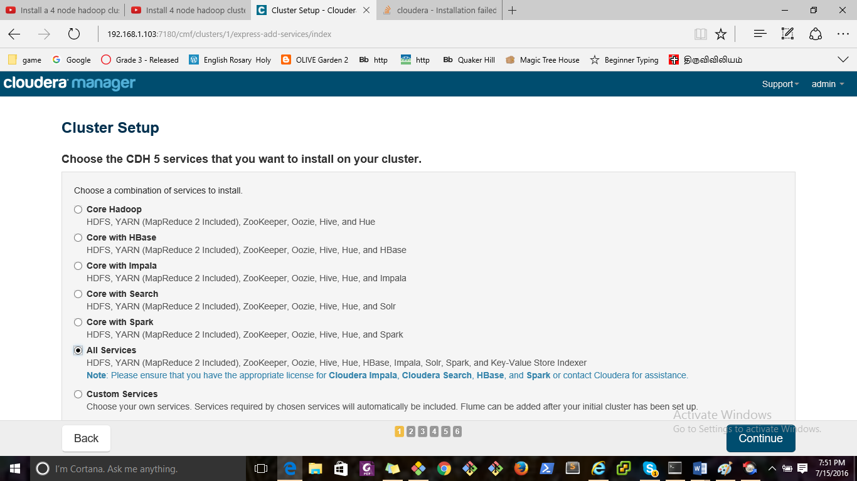

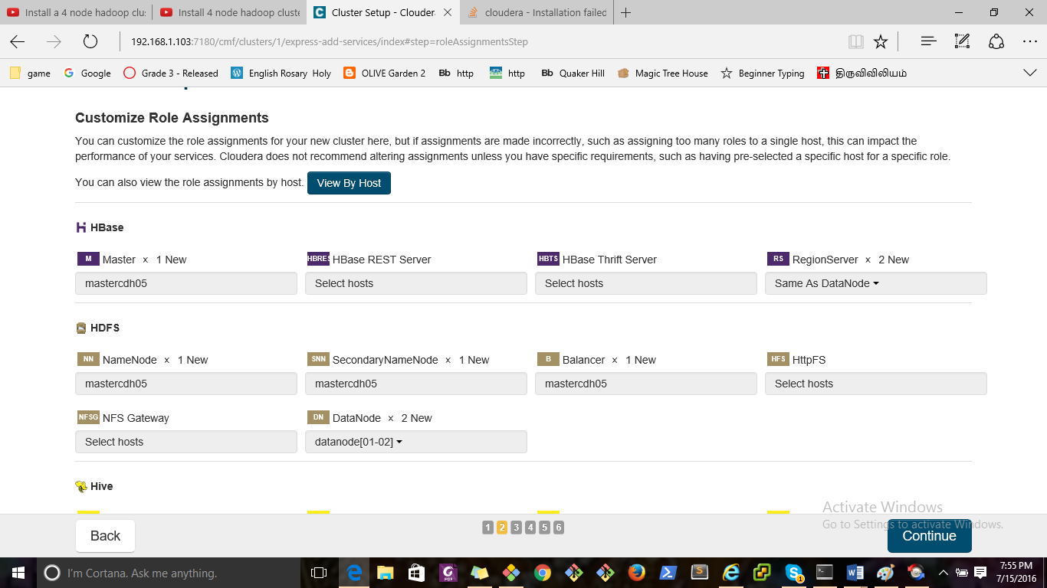

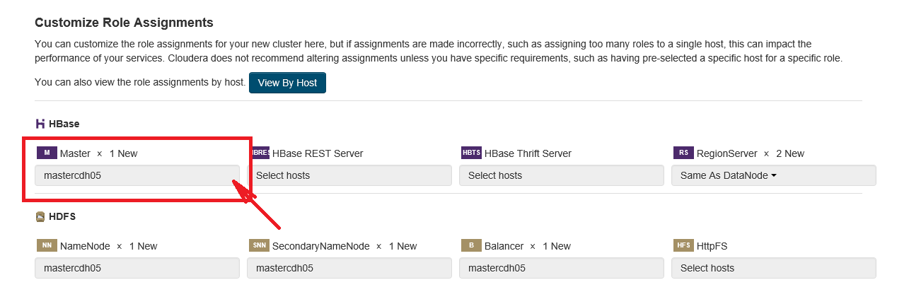

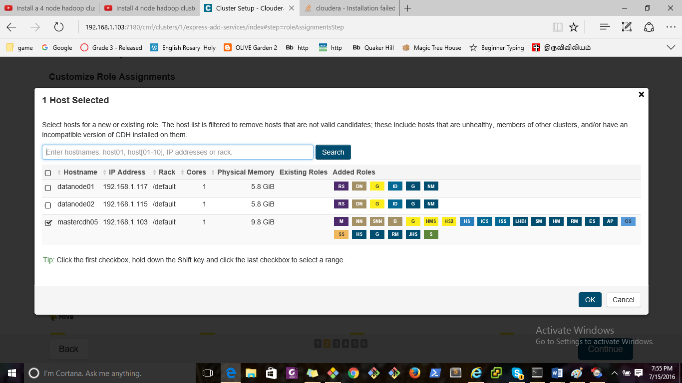

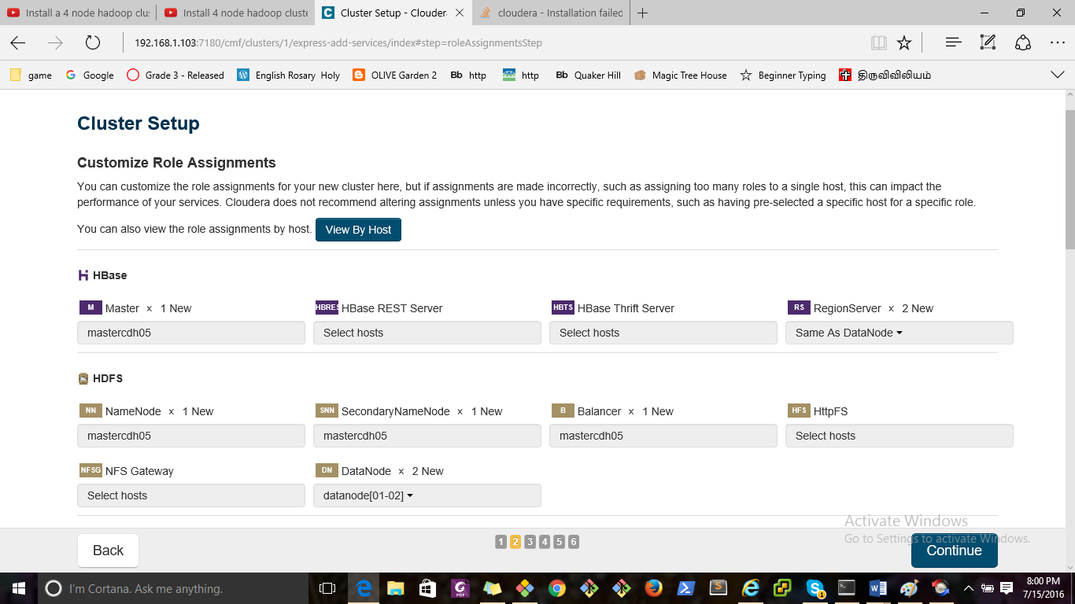

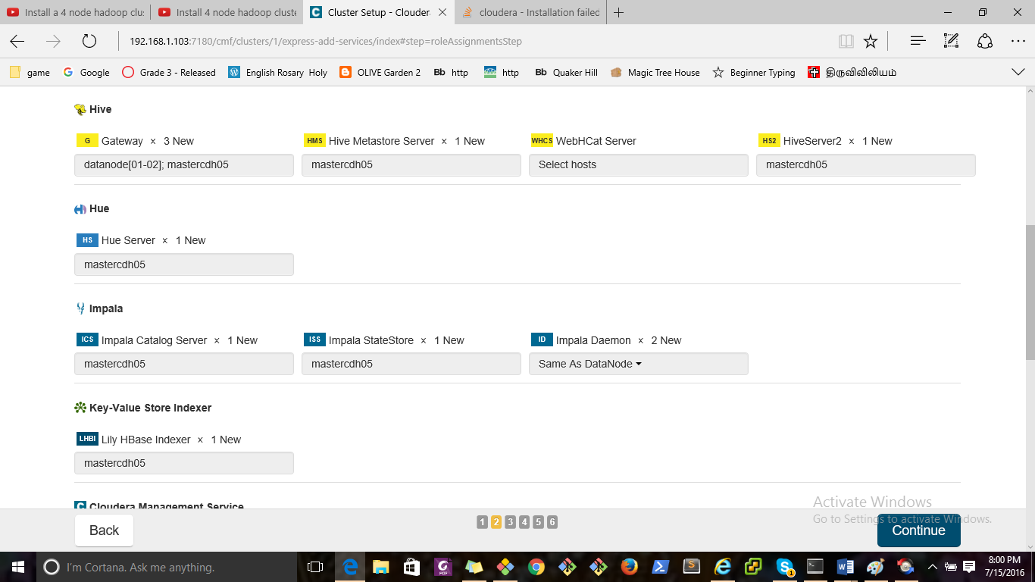

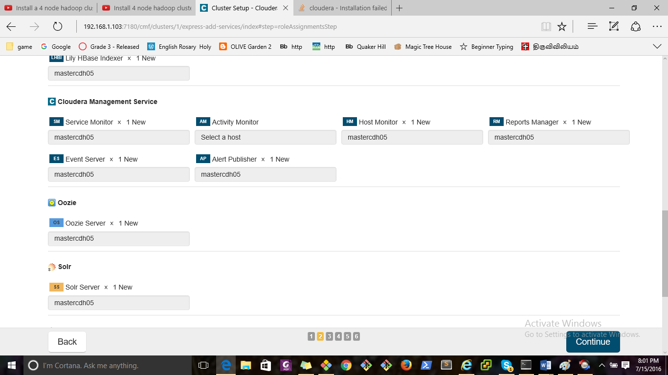

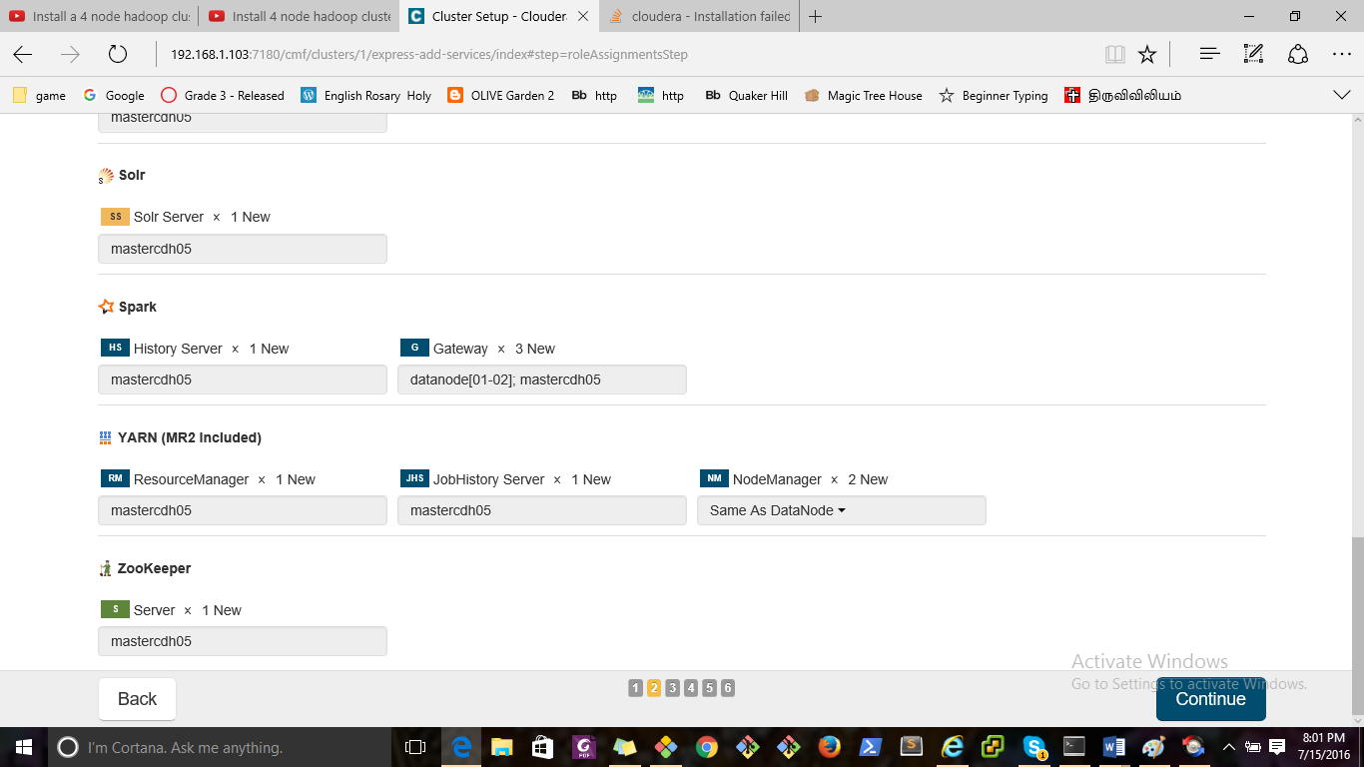

Installation Guide

<http://www.cloudera.com/documentation/enterprise/latest/topics/installation.html>

Cloudera Manager

[Support](http://192.168.1.103:7180/cmf/clusters/1/express-add-services/index)

[Support Portal](http://support.cloudera.com/)

[Scheduled Diagnostics: Weekly](http://192.168.1.103:7180/cmf/settings?groupKey=config.scm.support.display_group)

[Help](http://192.168.1.103:7180/cmf/help/scm-help-guide)

[Installation Guide](http://192.168.1.103:7180/cmf/help/scm-install-guide)

[API Documentation](http://192.168.1.103:7180/static/apidocs/)

[Release Notes](http://tiny.cloudera.com/cm-rel-notes-5.7)

[About](http://192.168.1.103:7180/cmf/help/about)

[admin](http://192.168.1.103:7180/cmf/clusters/1/express-add-services/index)

Full Administrator

[Change Password](http://192.168.1.103:7180/cmf/password)

[Logout](http://192.168.1.103:7180/cmf/logout)

×

Close

×

Confirm

OK Cancel

Cluster Setup

Choose the CDH 5 services that you want to install on your cluster.

Top of Form

Choose a combination of services to install.

Core Hadoop

HDFS, YARN (MapReduce 2 Included), ZooKeeper, Oozie, Hive, and Hue

Core with HBase

HDFS, YARN (MapReduce 2 Included), ZooKeeper, Oozie, Hive, Hue, and HBase

Note: Please ensure that you have the appropriate license for HBase or contact Cloudera for assistance.

Core with Impala

HDFS, YARN (MapReduce 2 Included), ZooKeeper, Oozie, Hive, Hue, and Impala

Note: Please ensure that you have the appropriate license for Cloudera Impala or contact Cloudera for assistance.

Core with Search

HDFS, YARN (MapReduce 2 Included), ZooKeeper, Oozie, Hive, Hue, and Solr

Note: Please ensure that you have the appropriate license for Cloudera Search or contact Cloudera for assistance.

Core with Spark

HDFS, YARN (MapReduce 2 Included), ZooKeeper, Oozie, Hive, Hue, and Spark

Note: Please ensure that you have the appropriate license for Spark or contact Cloudera for assistance.

All Services

HDFS, YARN (MapReduce 2 Included), ZooKeeper, Oozie, Hive, Hue, HBase, Impala, Solr, Spark, and Key-Value Store Indexer

Note: Please ensure that you have the appropriate license for Cloudera Impala, Cloudera Search, HBase, and Spark or contact Cloudera for assistance.

Custom Services

Choose your own services. Services required by chosen services will automatically be included. Flume can be added after your initial cluster has been set up.

|  | Service Type | Description |
| --- | --- | --- |
|  | HBase | Apache HBase provides random, real-time, read/write access to large data sets (requires HDFS and ZooKeeper). |
|  | HDFS | Apache Hadoop Distributed File System (HDFS) is the primary storage system used by Hadoop applications. HDFS creates multiple replicas of data blocks and distributes them on compute hosts throughout a cluster to enable reliable, extremely rapid computations. |
|  | Hive | Hive is a data warehouse system that offers a SQL-like language called HiveQL. |
|  | Hue | Hue is a graphical user interface to work with Cloudera's Distribution Including Apache Hadoop (requires HDFS, MapReduce, and Hive). |
|  | Impala | Impala provides a real-time SQL query interface for data stored in HDFS and HBase. Impala requres Hive service and shares Hive Metastore with Hue. |
|  | Isilon | EMC Isilon is a distributed filesystem. |
|  | Key-Value Store Indexer | Key-Value Store Indexer listens for changes in data inside tables contained in HBase and indexes them using Solr. |
|  | MapReduce | Apache Hadoop MapReduce supports distributed computing on large data sets across your cluster (requires HDFS). YARN (MapReduce 2 Included) is recommended instead. MapReduce is included for backward compatibility. |
|  | Oozie | Oozie is a workflow coordination service to manage data processing jobs on your cluster. |
|  | Solr | Solr is a distributed service for indexing and searching data stored in HDFS. |
|  | Spark | Apache Spark is an open source cluster computing system. This service runs Spark as an application on YARN. |
|  | Sqoop 2 | Sqoop is a tool designed for efficiently transferring bulk data between Apache Hadoop and structured datastores such as relational databases. The version supported by Cloudera Manager is Sqoop 2. |
|  | YARN (MR2 Included) | Apache Hadoop MapReduce 2.0 (MRv2), or YARN, is a data computation framework that supports MapReduce applications (requires HDFS). |
|  | ZooKeeper | Apache ZooKeeper is a centralized service for maintaining and synchronizing configuration data. |



This wizard will also install the Cloudera Management Service. These are a set of components that enable monitoring, reporting, events, and alerts; these components require databases to store information, which will be configured on the next page.

Include Cloudera Navigator

Please ensure that you have the appropriate license for Cloudera Navigator or contact Cloudera for assistance.

Some actions (for example, those performed by specific, internal users) are discarded by default. You can review and update these settings in the Audit Event Filter for each audited service.

Bottom of Form

Customize Role Assignments

Computing suggested role assignments. This may take a minute.

Top of Form

You can customize the role assignments for your new cluster here, but if assignments are made incorrectly, such as assigning too many roles to a single host, this can impact the performance of your services. Cloudera does not recommend altering assignments unless you have specific requirements, such as having pre-selected a specific host for a specific role.

You can also view the role assignments by host. [View By Host](http://192.168.1.103:7180/cmf/clusters/1/express-add-services/index)

HBase

M Master × 1 New

[mastercdh05](http://192.168.1.103:7180/cmf/clusters/1/express-add-services/index)

HBRESTS HBase REST Server

[Select hosts](http://192.168.1.103:7180/cmf/clusters/1/express-add-services/index)

HBTS HBase Thrift Server

[Select hosts](http://192.168.1.103:7180/cmf/clusters/1/express-add-services/index)

RS RegionServer × 2 New

[Same As DataNode](http://192.168.1.103:7180/cmf/clusters/1/express-add-services/index)

[All Hosts](http://192.168.1.103:7180/cmf/clusters/1/express-add-services/index)

[Same As DataNode](http://192.168.1.103:7180/cmf/clusters/1/express-add-services/index)

[Same As NodeManager](http://192.168.1.103:7180/cmf/clusters/1/express-add-services/index)

[Custom...](http://192.168.1.103:7180/cmf/clusters/1/express-add-services/index)

HDFS

NN NameNode × 1 New

[mastercdh05](http://192.168.1.103:7180/cmf/clusters/1/express-add-services/index)

SNN SecondaryNameNode × 1 New

[mastercdh05](http://192.168.1.103:7180/cmf/clusters/1/express-add-services/index)

B Balancer × 1 New

[mastercdh05](http://192.168.1.103:7180/cmf/clusters/1/express-add-services/index)

HFS HttpFS

[Select hosts](http://192.168.1.103:7180/cmf/clusters/1/express-add-services/index)

NFSG NFS Gateway

[Select hosts](http://192.168.1.103:7180/cmf/clusters/1/express-add-services/index)

DN DataNode × 2 New

[datanode[01-02]](http://192.168.1.103:7180/cmf/clusters/1/express-add-services/index)

[All Hosts](http://192.168.1.103:7180/cmf/clusters/1/express-add-services/index)

[Custom...](http://192.168.1.103:7180/cmf/clusters/1/express-add-services/index)

Hive

G Gateway × 3 New

[datanode[01-02]; mastercdh05](http://192.168.1.103:7180/cmf/clusters/1/express-add-services/index)

HMS Hive Metastore Server × 1 New

[mastercdh05](http://192.168.1.103:7180/cmf/clusters/1/express-add-services/index)

WHCS WebHCat Server

[Select hosts](http://192.168.1.103:7180/cmf/clusters/1/express-add-services/index)

HS2 HiveServer2 × 1 New

[mastercdh05](http://192.168.1.103:7180/cmf/clusters/1/express-add-services/index)

Hue

HS Hue Server × 1 New

[mastercdh05](http://192.168.1.103:7180/cmf/clusters/1/express-add-services/index)

Impala

ICS Impala Catalog Server × 1 New

[mastercdh05](http://192.168.1.103:7180/cmf/clusters/1/express-add-services/index)

ISS Impala StateStore × 1 New

[mastercdh05](http://192.168.1.103:7180/cmf/clusters/1/express-add-services/index)

ID Impala Daemon × 2 New

[Same As DataNode](http://192.168.1.103:7180/cmf/clusters/1/express-add-services/index)

[All Hosts](http://192.168.1.103:7180/cmf/clusters/1/express-add-services/index)

[Same As DataNode](http://192.168.1.103:7180/cmf/clusters/1/express-add-services/index)

[Same As NodeManager](http://192.168.1.103:7180/cmf/clusters/1/express-add-services/index)

[Same As RegionServer](http://192.168.1.103:7180/cmf/clusters/1/express-add-services/index)

[Custom...](http://192.168.1.103:7180/cmf/clusters/1/express-add-services/index)

Key-Value Store Indexer

LHBI Lily HBase Indexer × 1 New

[mastercdh05](http://192.168.1.103:7180/cmf/clusters/1/express-add-services/index)

Cloudera Management Service

SM Service Monitor × 1 New

[mastercdh05](http://192.168.1.103:7180/cmf/clusters/1/express-add-services/index)

AM Activity Monitor

[Select a host](http://192.168.1.103:7180/cmf/clusters/1/express-add-services/index)

HM Host Monitor × 1 New

[mastercdh05](http://192.168.1.103:7180/cmf/clusters/1/express-add-services/index)

RM Reports Manager × 1 New

[mastercdh05](http://192.168.1.103:7180/cmf/clusters/1/express-add-services/index)

ES Event Server × 1 New

[mastercdh05](http://192.168.1.103:7180/cmf/clusters/1/express-add-services/index)

AP Alert Publisher × 1 New

[mastercdh05](http://192.168.1.103:7180/cmf/clusters/1/express-add-services/index)

Oozie

OS Oozie Server × 1 New

[mastercdh05](http://192.168.1.103:7180/cmf/clusters/1/express-add-services/index)

Solr

SS Solr Server × 1 New

[mastercdh05](http://192.168.1.103:7180/cmf/clusters/1/express-add-services/index)

Spark

HS History Server × 1 New

[mastercdh05](http://192.168.1.103:7180/cmf/clusters/1/express-add-services/index)

G Gateway × 3 New

[datanode[01-02]; mastercdh05](http://192.168.1.103:7180/cmf/clusters/1/express-add-services/index)

YARN (MR2 Included)

RM ResourceManager × 1 New

[mastercdh05](http://192.168.1.103:7180/cmf/clusters/1/express-add-services/index)

JHS JobHistory Server × 1 New

[mastercdh05](http://192.168.1.103:7180/cmf/clusters/1/express-add-services/index)

NM NodeManager × 2 New

[Same As DataNode](http://192.168.1.103:7180/cmf/clusters/1/express-add-services/index)

[All Hosts](http://192.168.1.103:7180/cmf/clusters/1/express-add-services/index)

[Same As DataNode](http://192.168.1.103:7180/cmf/clusters/1/express-add-services/index)

[Custom...](http://192.168.1.103:7180/cmf/clusters/1/express-add-services/index)

ZooKeeper

S Server × 1 New

[mastercdh05](http://192.168.1.103:7180/cmf/clusters/1/express-add-services/index)

×

1 Host Selected

Select hosts for a new or existing role. The host list is filtered to remove hosts that are not valid candidates; these include hosts that are unhealthy, members of other clusters, and/or have an incompatible version of CDH installed on them.

Search

|  | Hostname | IP Address | Rack | Cores | Physical Memory | Existing Roles | Added Roles |
| --- | --- | --- | --- | --- | --- | --- | --- |
|  | datanode01 | 192.168.1.117 | /default | 1 | 5.8 GiB |  | RS DN G ID G NM RM |
|  | datanode02 | 192.168.1.115 | /default | 1 | 5.8 GiB |  | RS DN G ID G NM RM |
|  | mastercdh05 | 192.168.1.103 | /default | 1 | 9.8 GiB |  | M NN SNN B G HMS HS2 HS ICS ISS LHBI SM HM RM ES AP OS SS HS G RM JHS S |

Tip:Click the first checkbox, hold down the Shift key and click the last checkbox to select a range.

Showing 1 to 3 of 3 entries Display Per Page

OK Cancel

×

View By Host

| Hosts | Count | Existing Roles | Added Roles |
| --- | --- | --- | --- |
| datanode[01-02] | 2 |  | RS DN G ID G NM |
| mastercdh05 | 1 |  | M NN SNN B G HMS HS2 HS ICS ISS LHBI SM HM RM ES AP OS SS HS G RM JHS S |

This table is grouped by hosts having the same roles assigned to them.

Close

Bottom of Form

Database Setup

Computing required Database Setup. This may take a minute.

Top of Form

Database Setup

Configure and test database connections. If using custom databases, create the databases first according to the Installing and Configuring an External Database section of the [Installation Guide](http://192.168.1.103:7180/cmf/help/scm-install-guide).

Configure and test database connections. Create the databases first according to the Installing and Configuring an External Database section of the [Installation Guide](http://192.168.1.103:7180/cmf/help/scm-install-guide).

Use Custom DatabasesUse Embedded Database

When using the embedded database, passwords are automatically generated. Please copy them down.

|  |  |
| --- | --- |
| Hive |  |



|  |
| --- |
|  |
| Database Host Name: * | Database Type: | Database Name Database SID: * | Username: * | Password: |
| mastercdh05:7432 |  | hive | hive | Ru8cjRDNK2 |

|  |  |
| --- | --- |
| Reports Manager |  |



|  |  |  |  |  |
| --- | --- | --- | --- | --- |
| Currently assigned to run on mastercdh05. | | | | |
| Database Host Name: * | Database Type: | Database Name Database SID: * | Username: * | Password: |
| mastercdh05:7432 |  | rman | rman | tTIkvZxSqS |

|  |  |
| --- | --- |
| Oozie Server |  |



|  |  |  |  |  |
| --- | --- | --- | --- | --- |
| Currently assigned to run on mastercdh05. | | | | |
| Database Host Name: * | Database Type: | Database Name Database SID: * | Username: * | Password: |
| mastercdh05:7432 |  | oozie_oozie_server | oozie_oozie_server | qRAoabKiEN |

Show Password

Test Connection

Notes:

The value in the Database Host Name field must match the value you used for the host name when creating the database. [Learn more](http://192.168.1.103:7180/cmf/clusters/1/express-add-services/index)

If the database is not running on its default port, specify the port number using host:port in the Database Host Name field.

It is highly recommended that each database is on the same host as the corresponding role instance.

×

Help

The value you enter as the database host name must match the value you entered for the host name (if any) when you created the database (see Installing and Configuring an External Database).

For example, if you entered the following for the Activity Monitor database

grant all on activity_monitor.* TO 'amon_user'@'localhost' IDENTIFIED BY 'amon_password';

the value you enter here for the database host name must be localhost.

On the other hand, if you had entered the following when you created the database

grant all on activity_monitor.* TO 'amon_user'@'myhost-1.myco.com' IDENTIFIED BY 'amon_password';

the value you enter here for the database host name must be myhost-1.myco.com.

If you did not specify a host, or used a wildcard to allow access from any host, you can enter either the fully-qualified domain name (FQDN) here, or localhost. For example, if you entered

grant all on activity_monitor.* TO 'amon_user'@'%' IDENTIFIED BY 'amon_password';

the value you enter here for the database host name can be either the FQDN or localhost.

Similarly, if you entered

grant all on activity_monitor.* TO 'amon_user' IDENTIFIED BY 'amon_password';

the value you enter here for the database host name can be either the FQDN or localhost.

Close

Bottom of Form

Review Changes

Checking Review Changes. This may take a minute.

Review Changes

Command

Status: Running Context:

Start Time: Duration: Abort Aborting... Retry

This command's result data is no longer available. [Download Result Data](http://192.168.1.103:7180/cmf/command/-1/download)

All Failed Only Running Only

Details

Completed 0 of 0 step(s).

|  |  | Step | Context | Start Time | Duration | Actions |
| --- | --- | --- | --- | --- | --- | --- |

Display Per Page  |

[<<](http://192.168.1.103:7180/cmf/clusters/1/express-add-services/index)

[<](http://192.168.1.103:7180/cmf/clusters/1/express-add-services/index)

[>](http://192.168.1.103:7180/cmf/clusters/1/express-add-services/index)

Congratulations!

The services are installed, configured, and running on your cluster.

Back

1 2 3 4 5 6

Retry Continue

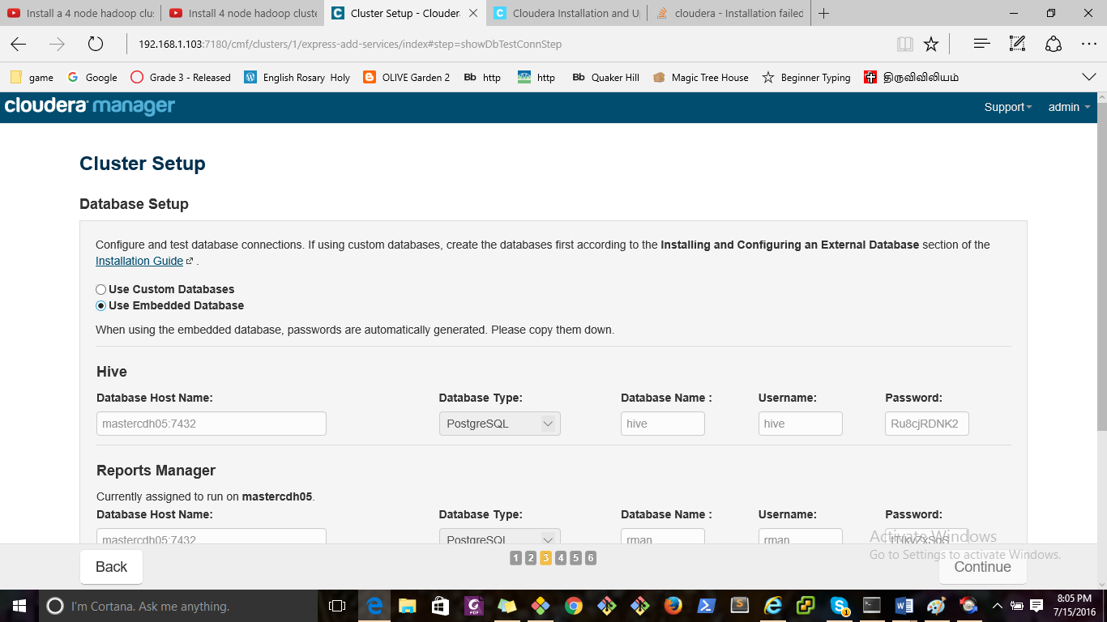

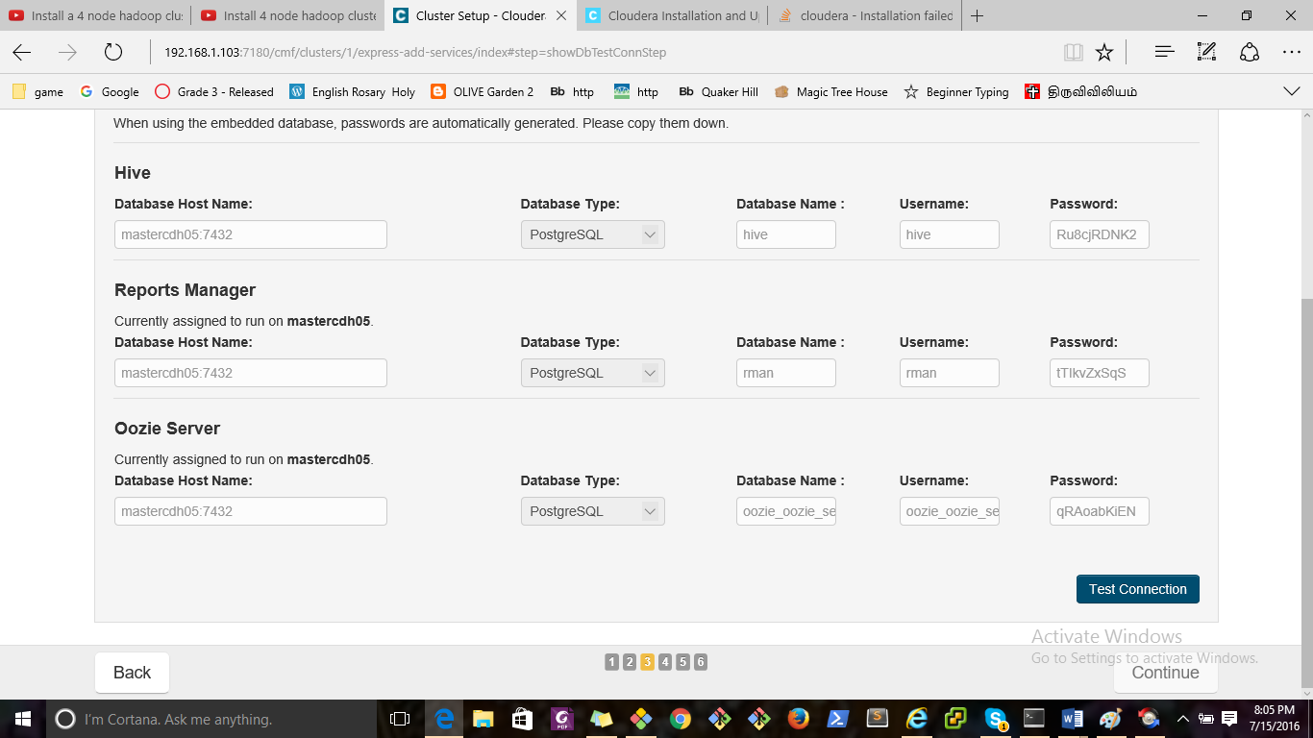

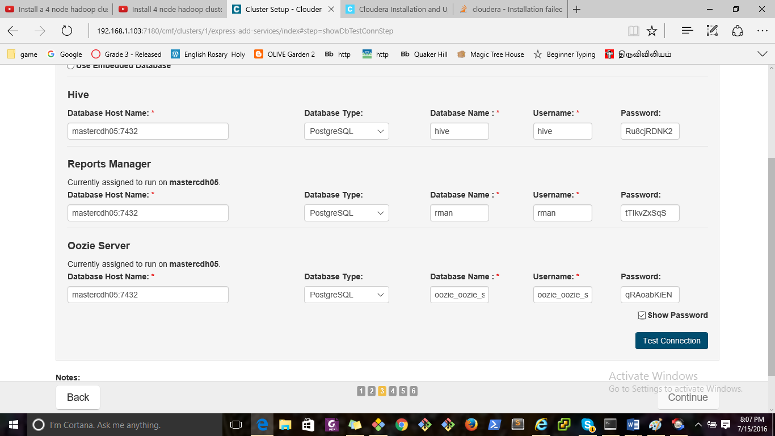

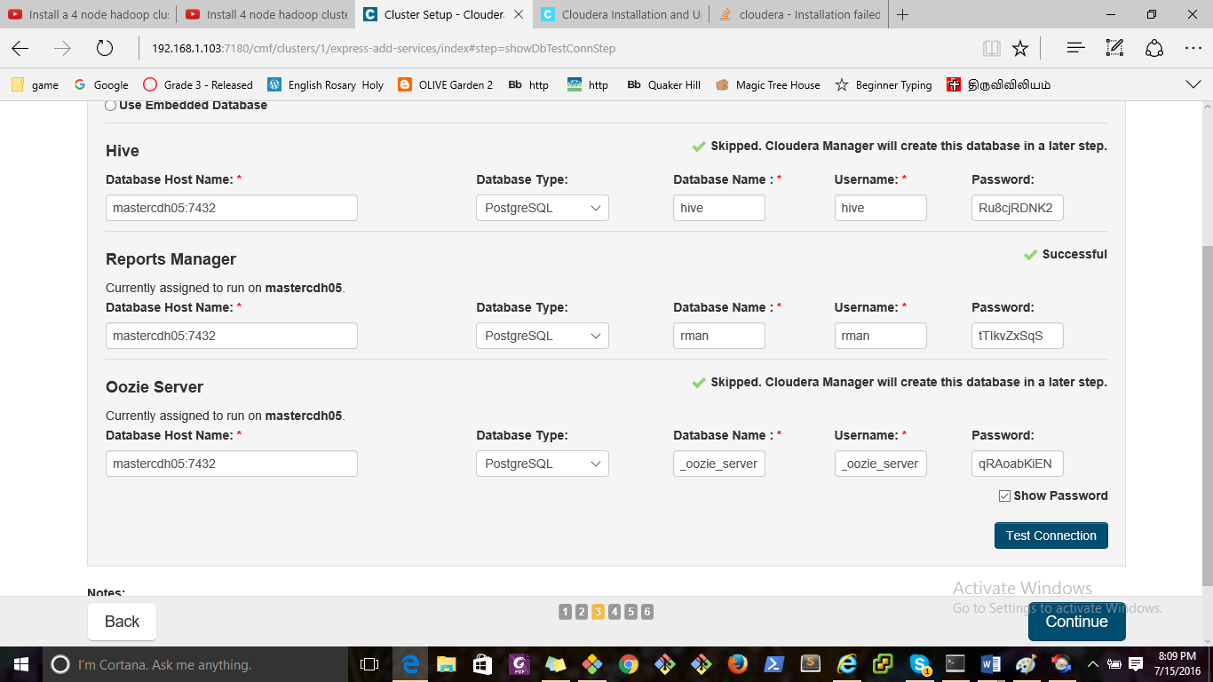

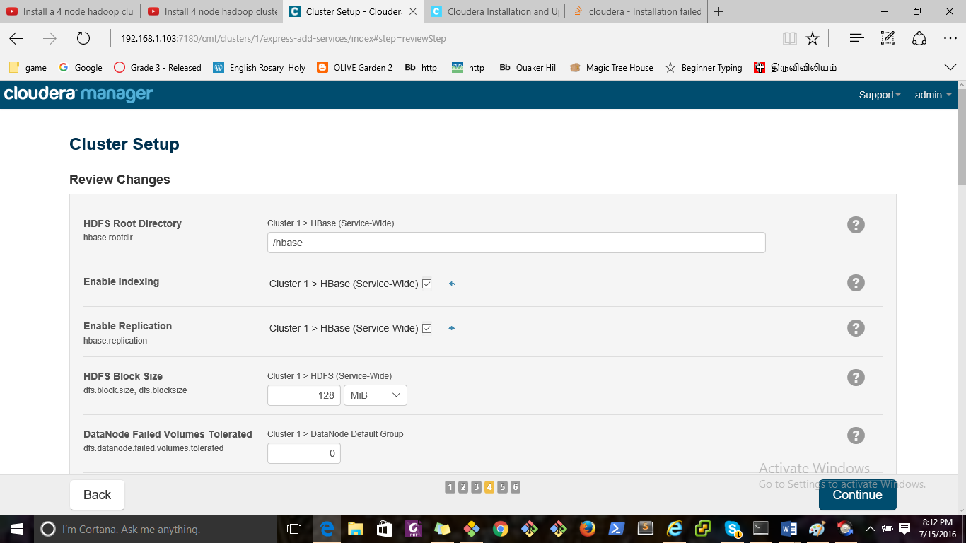

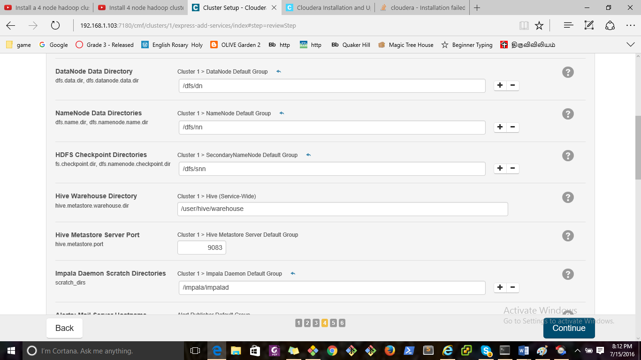

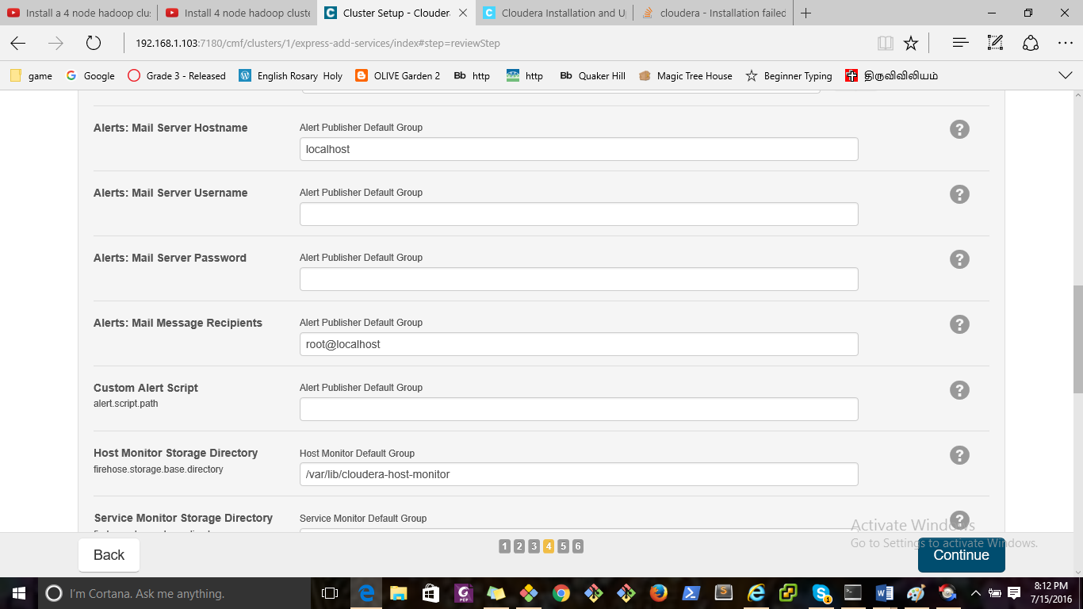

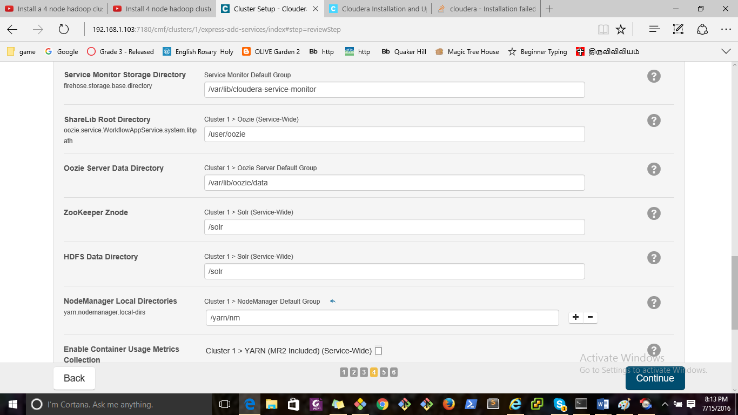

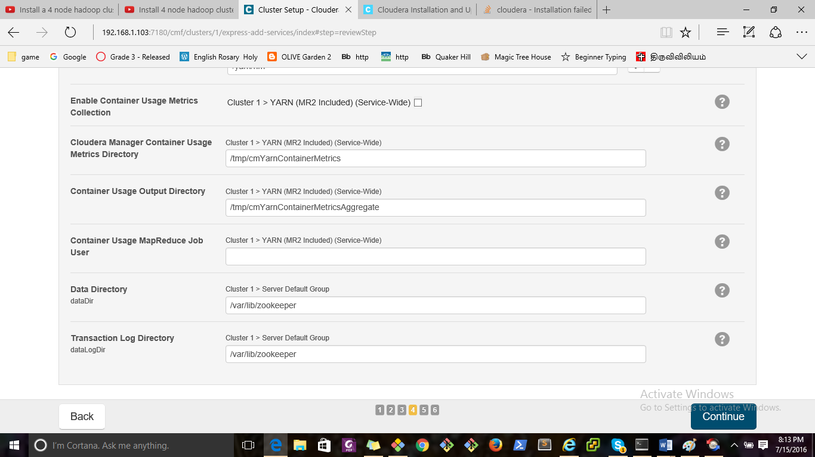

Cloudera Manager

[Support](http://192.168.1.103:7180/cmf/clusters/1/express-add-services/index)

[Support Portal](http://support.cloudera.com/)

[Scheduled Diagnostics: Weekly](http://192.168.1.103:7180/cmf/settings?groupKey=config.scm.support.display_group)

[Help](http://192.168.1.103:7180/cmf/help/scm-help-guide)

[Installation Guide](http://192.168.1.103:7180/cmf/help/scm-install-guide)

[API Documentation](http://192.168.1.103:7180/static/apidocs/)

[Release Notes](http://tiny.cloudera.com/cm-rel-notes-5.7)

[About](http://192.168.1.103:7180/cmf/help/about)

[admin](http://192.168.1.103:7180/cmf/clusters/1/express-add-services/index)

Full Administrator

[Change Password](http://192.168.1.103:7180/cmf/password)

[Logout](http://192.168.1.103:7180/cmf/logout)

×

Close

×

Confirm

OK Cancel

Cluster Setup

Choose the CDH 5 services that you want to install on your cluster.

Top of Form

Choose a combination of services to install.

Core Hadoop

HDFS, YARN (MapReduce 2 Included), ZooKeeper, Oozie, Hive, and Hue

Core with HBase

HDFS, YARN (MapReduce 2 Included), ZooKeeper, Oozie, Hive, Hue, and HBase

Note: Please ensure that you have the appropriate license for HBase or contact Cloudera for assistance.

Core with Impala

HDFS, YARN (MapReduce 2 Included), ZooKeeper, Oozie, Hive, Hue, and Impala

Note: Please ensure that you have the appropriate license for Cloudera Impala or contact Cloudera for assistance.

Core with Search

HDFS, YARN (MapReduce 2 Included), ZooKeeper, Oozie, Hive, Hue, and Solr

Note: Please ensure that you have the appropriate license for Cloudera Search or contact Cloudera for assistance.

Core with Spark

HDFS, YARN (MapReduce 2 Included), ZooKeeper, Oozie, Hive, Hue, and Spark

Note: Please ensure that you have the appropriate license for Spark or contact Cloudera for assistance.

All Services

HDFS, YARN (MapReduce 2 Included), ZooKeeper, Oozie, Hive, Hue, HBase, Impala, Solr, Spark, and Key-Value Store Indexer

Note: Please ensure that you have the appropriate license for Cloudera Impala, Cloudera Search, HBase, and Spark or contact Cloudera for assistance.

Custom Services

Choose your own services. Services required by chosen services will automatically be included. Flume can be added after your initial cluster has been set up.

|  | Service Type | Description |
| --- | --- | --- |
|  | HBase | Apache HBase provides random, real-time, read/write access to large data sets (requires HDFS and ZooKeeper). |
|  | HDFS | Apache Hadoop Distributed File System (HDFS) is the primary storage system used by Hadoop applications. HDFS creates multiple replicas of data blocks and distributes them on compute hosts throughout a cluster to enable reliable, extremely rapid computations. |
|  | Hive | Hive is a data warehouse system that offers a SQL-like language called HiveQL. |
|  | Hue | Hue is a graphical user interface to work with Cloudera's Distribution Including Apache Hadoop (requires HDFS, MapReduce, and Hive). |
|  | Impala | Impala provides a real-time SQL query interface for data stored in HDFS and HBase. Impala requres Hive service and shares Hive Metastore with Hue. |
|  | Isilon | EMC Isilon is a distributed filesystem. |
|  | Key-Value Store Indexer | Key-Value Store Indexer listens for changes in data inside tables contained in HBase and indexes them using Solr. |
|  | MapReduce | Apache Hadoop MapReduce supports distributed computing on large data sets across your cluster (requires HDFS). YARN (MapReduce 2 Included) is recommended instead. MapReduce is included for backward compatibility. |
|  | Oozie | Oozie is a workflow coordination service to manage data processing jobs on your cluster. |
|  | Solr | Solr is a distributed service for indexing and searching data stored in HDFS. |
|  | Spark | Apache Spark is an open source cluster computing system. This service runs Spark as an application on YARN. |
|  | Sqoop 2 | Sqoop is a tool designed for efficiently transferring bulk data between Apache Hadoop and structured datastores such as relational databases. The version supported by Cloudera Manager is Sqoop 2. |
|  | YARN (MR2 Included) | Apache Hadoop MapReduce 2.0 (MRv2), or YARN, is a data computation framework that supports MapReduce applications (requires HDFS). |
|  | ZooKeeper | Apache ZooKeeper is a centralized service for maintaining and synchronizing configuration data. |



This wizard will also install the Cloudera Management Service. These are a set of components that enable monitoring, reporting, events, and alerts; these components require databases to store information, which will be configured on the next page.

Include Cloudera Navigator

Please ensure that you have the appropriate license for Cloudera Navigator or contact Cloudera for assistance.

Some actions (for example, those performed by specific, internal users) are discarded by default. You can review and update these settings in the Audit Event Filter for each audited service.

Bottom of Form

Customize Role Assignments

Computing suggested role assignments. This may take a minute.

Top of Form

You can customize the role assignments for your new cluster here, but if assignments are made incorrectly, such as assigning too many roles to a single host, this can impact the performance of your services. Cloudera does not recommend altering assignments unless you have specific requirements, such as having pre-selected a specific host for a specific role.

You can also view the role assignments by host. [View By Host](http://192.168.1.103:7180/cmf/clusters/1/express-add-services/index)

HBase

M Master × 1 New

[mastercdh05](http://192.168.1.103:7180/cmf/clusters/1/express-add-services/index)

HBRESTS HBase REST Server

[Select hosts](http://192.168.1.103:7180/cmf/clusters/1/express-add-services/index)

HBTS HBase Thrift Server

[Select hosts](http://192.168.1.103:7180/cmf/clusters/1/express-add-services/index)

RS RegionServer × 2 New

[Same As DataNode](http://192.168.1.103:7180/cmf/clusters/1/express-add-services/index)

[All Hosts](http://192.168.1.103:7180/cmf/clusters/1/express-add-services/index)

[Same As DataNode](http://192.168.1.103:7180/cmf/clusters/1/express-add-services/index)

[Same As NodeManager](http://192.168.1.103:7180/cmf/clusters/1/express-add-services/index)

[Custom...](http://192.168.1.103:7180/cmf/clusters/1/express-add-services/index)

HDFS

NN NameNode × 1 New

[mastercdh05](http://192.168.1.103:7180/cmf/clusters/1/express-add-services/index)

SNN SecondaryNameNode × 1 New

[mastercdh05](http://192.168.1.103:7180/cmf/clusters/1/express-add-services/index)

B Balancer × 1 New

[mastercdh05](http://192.168.1.103:7180/cmf/clusters/1/express-add-services/index)

HFS HttpFS

[Select hosts](http://192.168.1.103:7180/cmf/clusters/1/express-add-services/index)

NFSG NFS Gateway

[Select hosts](http://192.168.1.103:7180/cmf/clusters/1/express-add-services/index)

DN DataNode × 2 New

[datanode[01-02]](http://192.168.1.103:7180/cmf/clusters/1/express-add-services/index)

[All Hosts](http://192.168.1.103:7180/cmf/clusters/1/express-add-services/index)

[Custom...](http://192.168.1.103:7180/cmf/clusters/1/express-add-services/index)

Hive

G Gateway × 3 New

[datanode[01-02]; mastercdh05](http://192.168.1.103:7180/cmf/clusters/1/express-add-services/index)

HMS Hive Metastore Server × 1 New

[mastercdh05](http://192.168.1.103:7180/cmf/clusters/1/express-add-services/index)

WHCS WebHCat Server

[Select hosts](http://192.168.1.103:7180/cmf/clusters/1/express-add-services/index)

HS2 HiveServer2 × 1 New

[mastercdh05](http://192.168.1.103:7180/cmf/clusters/1/express-add-services/index)

Hue

HS Hue Server × 1 New

[mastercdh05](http://192.168.1.103:7180/cmf/clusters/1/express-add-services/index)

Impala

ICS Impala Catalog Server × 1 New

[mastercdh05](http://192.168.1.103:7180/cmf/clusters/1/express-add-services/index)

ISS Impala StateStore × 1 New

[mastercdh05](http://192.168.1.103:7180/cmf/clusters/1/express-add-services/index)

ID Impala Daemon × 2 New

[Same As DataNode](http://192.168.1.103:7180/cmf/clusters/1/express-add-services/index)

[All Hosts](http://192.168.1.103:7180/cmf/clusters/1/express-add-services/index)

[Same As DataNode](http://192.168.1.103:7180/cmf/clusters/1/express-add-services/index)

[Same As NodeManager](http://192.168.1.103:7180/cmf/clusters/1/express-add-services/index)

[Same As RegionServer](http://192.168.1.103:7180/cmf/clusters/1/express-add-services/index)

[Custom...](http://192.168.1.103:7180/cmf/clusters/1/express-add-services/index)

Key-Value Store Indexer

LHBI Lily HBase Indexer × 1 New

[mastercdh05](http://192.168.1.103:7180/cmf/clusters/1/express-add-services/index)

Cloudera Management Service

SM Service Monitor × 1 New

[mastercdh05](http://192.168.1.103:7180/cmf/clusters/1/express-add-services/index)

AM Activity Monitor

[Select a host](http://192.168.1.103:7180/cmf/clusters/1/express-add-services/index)

HM Host Monitor × 1 New

[mastercdh05](http://192.168.1.103:7180/cmf/clusters/1/express-add-services/index)

RM Reports Manager × 1 New

[mastercdh05](http://192.168.1.103:7180/cmf/clusters/1/express-add-services/index)

ES Event Server × 1 New

[mastercdh05](http://192.168.1.103:7180/cmf/clusters/1/express-add-services/index)

AP Alert Publisher × 1 New

[mastercdh05](http://192.168.1.103:7180/cmf/clusters/1/express-add-services/index)

Oozie

OS Oozie Server × 1 New

[mastercdh05](http://192.168.1.103:7180/cmf/clusters/1/express-add-services/index)

Solr

SS Solr Server × 1 New

[mastercdh05](http://192.168.1.103:7180/cmf/clusters/1/express-add-services/index)

Spark

HS History Server × 1 New

[mastercdh05](http://192.168.1.103:7180/cmf/clusters/1/express-add-services/index)

G Gateway × 3 New

[datanode[01-02]; mastercdh05](http://192.168.1.103:7180/cmf/clusters/1/express-add-services/index)

YARN (MR2 Included)

RM ResourceManager × 1 New

[mastercdh05](http://192.168.1.103:7180/cmf/clusters/1/express-add-services/index)

JHS JobHistory Server × 1 New

[mastercdh05](http://192.168.1.103:7180/cmf/clusters/1/express-add-services/index)

NM NodeManager × 2 New

[Same As DataNode](http://192.168.1.103:7180/cmf/clusters/1/express-add-services/index)

[All Hosts](http://192.168.1.103:7180/cmf/clusters/1/express-add-services/index)

[Same As DataNode](http://192.168.1.103:7180/cmf/clusters/1/express-add-services/index)

[Custom...](http://192.168.1.103:7180/cmf/clusters/1/express-add-services/index)

ZooKeeper

S Server × 1 New

[mastercdh05](http://192.168.1.103:7180/cmf/clusters/1/express-add-services/index)

×

1 Host Selected

Select hosts for a new or existing role. The host list is filtered to remove hosts that are not valid candidates; these include hosts that are unhealthy, members of other clusters, and/or have an incompatible version of CDH installed on them.

Search

|  | Hostname | IP Address | Rack | Cores | Physical Memory | Existing Roles | Added Roles |
| --- | --- | --- | --- | --- | --- | --- | --- |
|  | datanode01 | 192.168.1.117 | /default | 1 | 5.8 GiB |  | RS DN G ID G NM RM |
|  | datanode02 | 192.168.1.115 | /default | 1 | 5.8 GiB |  | RS DN G ID G NM RM |
|  | mastercdh05 | 192.168.1.103 | /default | 1 | 9.8 GiB |  | M NN SNN B G HMS HS2 HS ICS ISS LHBI SM HM RM ES AP OS SS HS G RM JHS S |

Tip:Click the first checkbox, hold down the Shift key and click the last checkbox to select a range.

Showing 1 to 3 of 3 entries Display Per Page

OK Cancel

×

View By Host

| Hosts | Count | Existing Roles | Added Roles |
| --- | --- | --- | --- |
| datanode[01-02] | 2 |  | RS DN G ID G NM |
| mastercdh05 | 1 |  | M NN SNN B G HMS HS2 HS ICS ISS LHBI SM HM RM ES AP OS SS HS G RM JHS S |

This table is grouped by hosts having the same roles assigned to them.

Close

Bottom of Form

Database Setup

Computing required Database Setup. This may take a minute.

Top of Form

Database Setup

Configure and test database connections. If using custom databases, create the databases first according to the Installing and Configuring an External Database section of the [Installation Guide](http://192.168.1.103:7180/cmf/help/scm-install-guide).

Configure and test database connections. Create the databases first according to the Installing and Configuring an External Database section of the [Installation Guide](http://192.168.1.103:7180/cmf/help/scm-install-guide).

Use Custom DatabasesUse Embedded Database

When using the embedded database, passwords are automatically generated. Please copy them down.

|  |  |
| --- | --- |
| Hive | Skipped. Cloudera Manager will create this database in a later step. |



|  |
| --- |
|  |
| Database Host Name: * | Database Type: | Database Name Database SID: * | Username: * | Password: |
| mastercdh05:7432 |  | hive | hive | Ru8cjRDNK2 |

|  |  |
| --- | --- |
| Reports Manager | Successful |



|  |  |  |  |  |
| --- | --- | --- | --- | --- |
| Currently assigned to run on mastercdh05. | | | | |
| Database Host Name: * | Database Type: | Database Name Database SID: * | Username: * | Password: |
| mastercdh05:7432 |  | rman | rman | tTIkvZxSqS |

|  |  |
| --- | --- |
| Oozie Server | Skipped. Cloudera Manager will create this database in a later step. |



|  |  |  |  |  |
| --- | --- | --- | --- | --- |
| Currently assigned to run on mastercdh05. | | | | |
| Database Host Name: * | Database Type: | Database Name Database SID: * | Username: * | Password: |
| mastercdh05:7432 |  | oozie_oozie_server | oozie_oozie_server | qRAoabKiEN |

Show Password

Test Connection

Notes:

The value in the Database Host Name field must match the value you used for the host name when creating the database. [Learn more](http://192.168.1.103:7180/cmf/clusters/1/express-add-services/index)

If the database is not running on its default port, specify the port number using host:port in the Database Host Name field.

It is highly recommended that each database is on the same host as the corresponding role instance.

×

Help

The value you enter as the database host name must match the value you entered for the host name (if any) when you created the database (see Installing and Configuring an External Database).

For example, if you entered the following for the Activity Monitor database

grant all on activity_monitor.* TO 'amon_user'@'localhost' IDENTIFIED BY 'amon_password';

the value you enter here for the database host name must be localhost.

On the other hand, if you had entered the following when you created the database

grant all on activity_monitor.* TO 'amon_user'@'myhost-1.myco.com' IDENTIFIED BY 'amon_password';

the value you enter here for the database host name must be myhost-1.myco.com.

If you did not specify a host, or used a wildcard to allow access from any host, you can enter either the fully-qualified domain name (FQDN) here, or localhost. For example, if you entered

grant all on activity_monitor.* TO 'amon_user'@'%' IDENTIFIED BY 'amon_password';

the value you enter here for the database host name can be either the FQDN or localhost.

Similarly, if you entered

grant all on activity_monitor.* TO 'amon_user' IDENTIFIED BY 'amon_password';

the value you enter here for the database host name can be either the FQDN or localhost.

Close

Bottom of Form

Review Changes

Checking Review Changes. This may take a minute.

Review Changes

HDFS Root Directory

hbase.rootdir

0 overrides removed

Requires Agent Restart

Requires Server Restart

Edit Identical Values

Edit Individual Values

Cluster 1 > HBase (Service-Wide)



Manage Host Overrides

The HDFS directory shared by HBase RegionServers.

Enable Indexing

0 overrides removed

Requires Agent Restart

Requires Server Restart

Edit Identical Values

Edit Individual Values

Cluster 1 > HBase (Service-Wide)



Manage Host Overrides

Allow indexing of tables in HBase by Lily HBase Indexer. Note: Replication must be enabled for indexing to work.

Enable Replication

hbase.replication

0 overrides removed

Requires Agent Restart

Requires Server Restart

Edit Identical Values

Edit Individual Values

Cluster 1 > HBase (Service-Wide)



Manage Host Overrides

Allow HBase tables to be replicated.

HDFS Block Size

dfs.block.size, dfs.blocksize

0 overrides removed

Requires Agent Restart

Requires Server Restart

Edit Identical Values

Edit Individual Values

Cluster 1 > HDFS (Service-Wide)



Manage Host Overrides

The default block size in bytes for new HDFS files. Note that this value is also used as the HBase Region Server HLog block size.

DataNode Failed Volumes Tolerated

dfs.datanode.failed.volumes.tolerated

0 overrides removed

Requires Agent Restart

Requires Server Restart

Edit Identical Values

Edit Individual Values

Cluster 1 > DataNode Default Group



Manage Host Overrides

The number of volumes that are allowed to fail before a DataNode stops offering service. By default, any volume failure will cause a DataNode to shutdown.

DataNode Data Directory

dfs.data.dir, dfs.datanode.data.dir

0 overrides removed

Requires Agent Restart

Requires Server Restart

Edit Identical Values

Edit Individual Values

Cluster 1 > DataNode Default Group



Manage Host Overrides

Comma-delimited list of directories on the local file system where the DataNode stores HDFS block data. Typical values are /data/N/dfs/dn for N = 1, 2, 3.... In CDH 5.7 and higher, these directories can be optionally tagged with their storage types, e.g., [SSD]/data/1/dns/dn. HDFS supports the following storage types: [DISK], [SSD], [ARCHIVE], [RAM_DISK]. The default storage type of a directory will be [DISK] if it does not have a storage type tagged explicitly. These directories should be mounted using the noatime option, and the disks should be configured using JBOD. RAID is not recommended. Warning: Be very careful when modifying this property. Removing or changing entries can result in data loss. To hot swap drives in CDH 5.4 and higher, override the value of this property for the specific DataNode role instance that has the drive to be hot-swapped; do not modify the property value in the role group. See [Configuring Hot Swap for DataNodes](http://tiny.cloudera.com/hot-swap) for more information.

NameNode Data Directories

dfs.name.dir, dfs.namenode.name.dir

0 overrides removed

Requires Agent Restart

Requires Server Restart

Edit Identical Values

Edit Individual Values

Cluster 1 > NameNode Default Group



Manage Host Overrides

Determines where on the local file system the NameNode should store the name table (fsimage). For redundancy, enter a comma-delimited list of directories to replicate the name table in all of the directories. Typical values are /data/N/dfs/nn where N=1..3.

HDFS Checkpoint Directories

fs.checkpoint.dir, dfs.namenode.checkpoint.dir

0 overrides removed

Requires Agent Restart

Requires Server Restart

Edit Identical Values

Edit Individual Values

Cluster 1 > SecondaryNameNode Default Group



Manage Host Overrides

Determines where on the local file system the HDFS SecondaryNameNode should store the temporary images to merge. For redundancy, enter a comma-delimited list of directories to replicate the image in all of the directories. Typical values are /data/N/dfs/snn for N = 1, 2, 3...

Hive Warehouse Directory

hive.metastore.warehouse.dir

0 overrides removed

Requires Agent Restart

Requires Server Restart

Edit Identical Values

Edit Individual Values

Cluster 1 > Hive (Service-Wide)



Manage Host Overrides

Hive warehouse directory is the location in HDFS where Hive's tables are stored. Note that Hive's default value for its warehouse directory is '/user/hive/warehouse'.

Hive Metastore Server Port

hive.metastore.port

0 overrides removed

Requires Agent Restart

Requires Server Restart

Edit Identical Values

Edit Individual Values

Cluster 1 > Hive Metastore Server Default Group



Manage Host Overrides

Port on which Hive Metastore Server will listen for connections.

Impala Daemon Scratch Directories

scratch_dirs

0 overrides removed

Requires Agent Restart

Requires Server Restart

Edit Identical Values

Edit Individual Values

Cluster 1 > Impala Daemon Default Group



Manage Host Overrides

Directories where Impala Daemon will write data such as spilling information to disk to free up memory. This can potentially be large amounts of data.

Alerts: Mail Server Hostname

0 overrides removed

Requires Agent Restart

Requires Server Restart

Edit Identical Values

Edit Individual Values

Alert Publisher Default Group



Manage Host Overrides

The IP address or hostname of the mail server to send alerts to

Alerts: Mail Server Username

0 overrides removed

Requires Agent Restart

Requires Server Restart

Edit Identical Values

Edit Individual Values

Alert Publisher Default Group



Manage Host Overrides

The username to use to log into the mail server

Alerts: Mail Server Password

0 overrides removed

Requires Agent Restart

Requires Server Restart

Edit Identical Values

Edit Individual Values

Alert Publisher Default Group



Manage Host Overrides

The password to use to log into the mail server. Warning: this password will be sent over the network to the Alert Publisher host in clear text. In addition, the password will be stored in a plain text file on the Alert Publisher host with restrictive file system permissions.

Alerts: Mail Message Recipients

0 overrides removed

Requires Agent Restart

Requires Server Restart

Edit Identical Values

Edit Individual Values

Alert Publisher Default Group



Manage Host Overrides

A comma-separated list of email addresses to send alerts to

Custom Alert Script

alert.script.path

0 overrides removed

Requires Agent Restart

Requires Server Restart

Edit Identical Values

Edit Individual Values

Alert Publisher Default Group



Manage Host Overrides

If configured, this script is invoked on the machine hosting the alert publisher role. The script must be readable and executable by the cloudera-scm user. The script is passed, as a single argument, a path to a UTF-8 JSON file containing a list of alerts. Alerts are, by default, batched over time, and the batch size and the batch interval are configurable with the "Alert Publisher: Maximum Batch Size" and "Alert Publisher: Maximum Batch Interval" configuration options. The alerts file is deleted when the script finishes executing. Only one instance of this script is invoked at any given time, and the script must terminate. The standard out and standard error messages from this script are logged to the alert publisher role's log file.

Host Monitor Storage Directory

firehose.storage.base.directory

0 overrides removed

Requires Agent Restart

Requires Server Restart

Edit Identical Values

Edit Individual Values

Host Monitor Default Group



Manage Host Overrides

The directory where Host Monitor data is stored. The Host Monitor stores metric time series and health information.

Service Monitor Storage Directory

firehose.storage.base.directory

0 overrides removed

Requires Agent Restart

Requires Server Restart

Edit Identical Values

Edit Individual Values

Service Monitor Default Group



Manage Host Overrides

The directory where Service Monitor data is stored. The Service Monitor stores metric time series and health information, as well as Impala query and YARN application metadata if Impala and/or YARN are configured.

ShareLib Root Directory

oozie.service.WorkflowAppService.system.libpath

0 overrides removed

Requires Agent Restart

Requires Server Restart

Edit Identical Values

Edit Individual Values

Cluster 1 > Oozie (Service-Wide)



Manage Host Overrides

Root of the directory in HDFS where the Oozie ShareLibs are stored. The libraries are stored in the share/lib subdirectory under the specified root directory.

Oozie Server Data Directory

0 overrides removed

Requires Agent Restart

Requires Server Restart

Edit Identical Values

Edit Individual Values

Cluster 1 > Oozie Server Default Group



Manage Host Overrides

Directory where the Oozie Server places its data. Only applicable when using Derby as the database type.

ZooKeeper Znode

0 overrides removed

Requires Agent Restart

Requires Server Restart

Edit Identical Values

Edit Individual Values

Cluster 1 > Solr (Service-Wide)



Manage Host Overrides

ZooKeeper znode used to store information about this Solr service.

HDFS Data Directory

0 overrides removed

Requires Agent Restart

Requires Server Restart

Edit Identical Values

Edit Individual Values

Cluster 1 > Solr (Service-Wide)



Manage Host Overrides

HDFS directory used for storage by this Solr service.

NodeManager Local Directories

yarn.nodemanager.local-dirs

0 overrides removed

Requires Agent Restart

Requires Server Restart

Edit Identical Values

Edit Individual Values

Cluster 1 > NodeManager Default Group



Manage Host Overrides

List of directories on the local filesystem where a NodeManager stores intermediate data files.

Enable Container Usage Metrics Collection

0 overrides removed

Requires Agent Restart

Requires Server Restart

Edit Identical Values

Edit Individual Values

Cluster 1 > YARN (MR2 Included) (Service-Wide)



Manage Host Overrides

Enables storing YARN container usage metrics in HDFS and periodically running a MapReduce job from Cloudera Service Monitor to aggregate them into per application metrics. This is needed for YARN usage reporting feature to work.

Cloudera Manager Container Usage Metrics Directory

0 overrides removed

Requires Agent Restart

Requires Server Restart

Edit Identical Values

Edit Individual Values

Cluster 1 > YARN (MR2 Included) (Service-Wide)



Manage Host Overrides

DFS directory where the container usage metrics from Cloudera Manager sink are stored by YARN NodeManagers. Cloudera Service Monitor will read the container usage metrics and aggregate them for generating usage reports. Note: If you change this, you will need to re-run the Create YARN Container Usage Metrics Dir command.

Container Usage Output Directory

0 overrides removed

Requires Agent Restart

Requires Server Restart

Edit Identical Values

Edit Individual Values

Cluster 1 > YARN (MR2 Included) (Service-Wide)



Manage Host Overrides

DFS directory where the aggregated container usage metrics are stored by Cloudera Service Monitor. This directory is created by Cloudera Service Monitor before running the usage aggregation MapReduce job for the first time.

Container Usage MapReduce Job User

0 overrides removed

Requires Agent Restart

Requires Server Restart

Edit Identical Values

Edit Individual Values

Cluster 1 > YARN (MR2 Included) (Service-Wide)



Manage Host Overrides

User which Cloudera Service Monitor uses to run the MapReduce job to aggregate container usage metrics. Note: If you change this user, you will need to change the owner of the existing Container Usage Metrics and Output Directories.

Data Directory

dataDir

0 overrides removed

Requires Agent Restart

Requires Server Restart

Edit Identical Values

Edit Individual Values

Cluster 1 > Server Default Group



Manage Host Overrides

The disk location that ZooKeeper will use to store its database snapshots.

Transaction Log Directory

dataLogDir

0 overrides removed

Requires Agent Restart

Requires Server Restart

Edit Identical Values

Edit Individual Values

Cluster 1 > Server Default Group



Manage Host Overrides

The disk location that ZooKeeper will use to store its transaction logs.

Command

Status: Running Context:

Start Time: Duration: Abort Aborting... Retry

This command's result data is no longer available. [Download Result Data](http://192.168.1.103:7180/cmf/command/-1/download)

All Failed Only Running Only

Details

Completed 0 of 0 step(s).

|  |  | Step | Context | Start Time | Duration | Actions |
| --- | --- | --- | --- | --- | --- | --- |

Display Per Page  |

[<<](http://192.168.1.103:7180/cmf/clusters/1/express-add-services/index)

[<](http://192.168.1.103:7180/cmf/clusters/1/express-add-services/index)

[>](http://192.168.1.103:7180/cmf/clusters/1/express-add-services/index)

Congratulations!

The services are installed, configured, and running on your cluster.

Back

1 2 3 4 5 6

Retry Continue

sudo service cloudera-scm-server restart